***TYPE CASTING***



**BY**

**EEMANI VIVEK**

**BYTE TO SHORT**

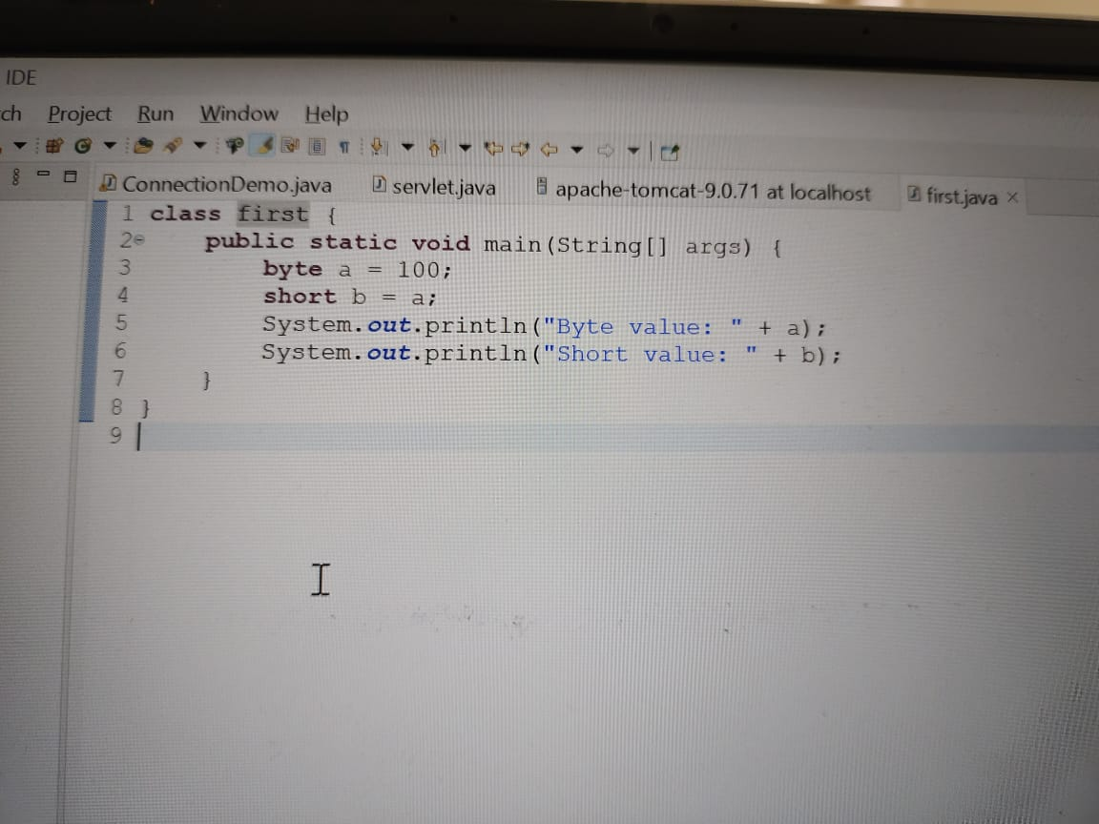

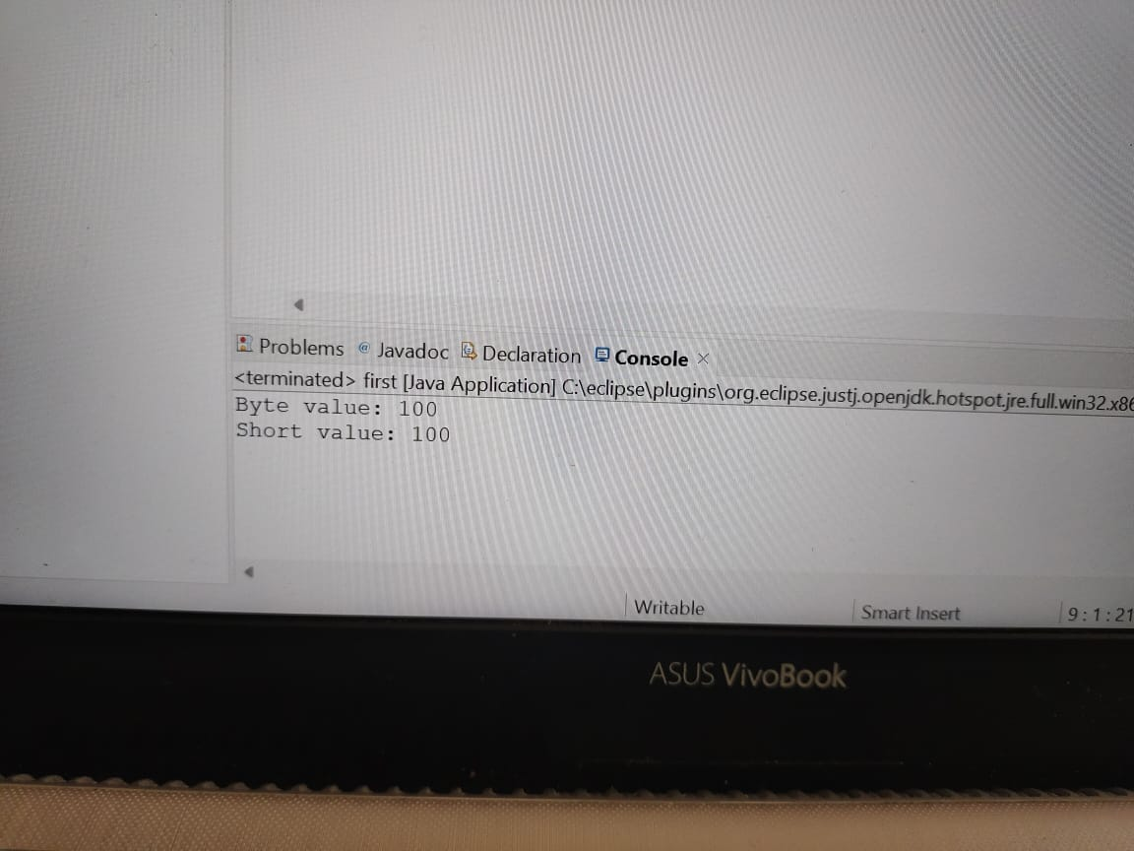

**IMPLICIT CONVERSION**

**BYTE TO INT**

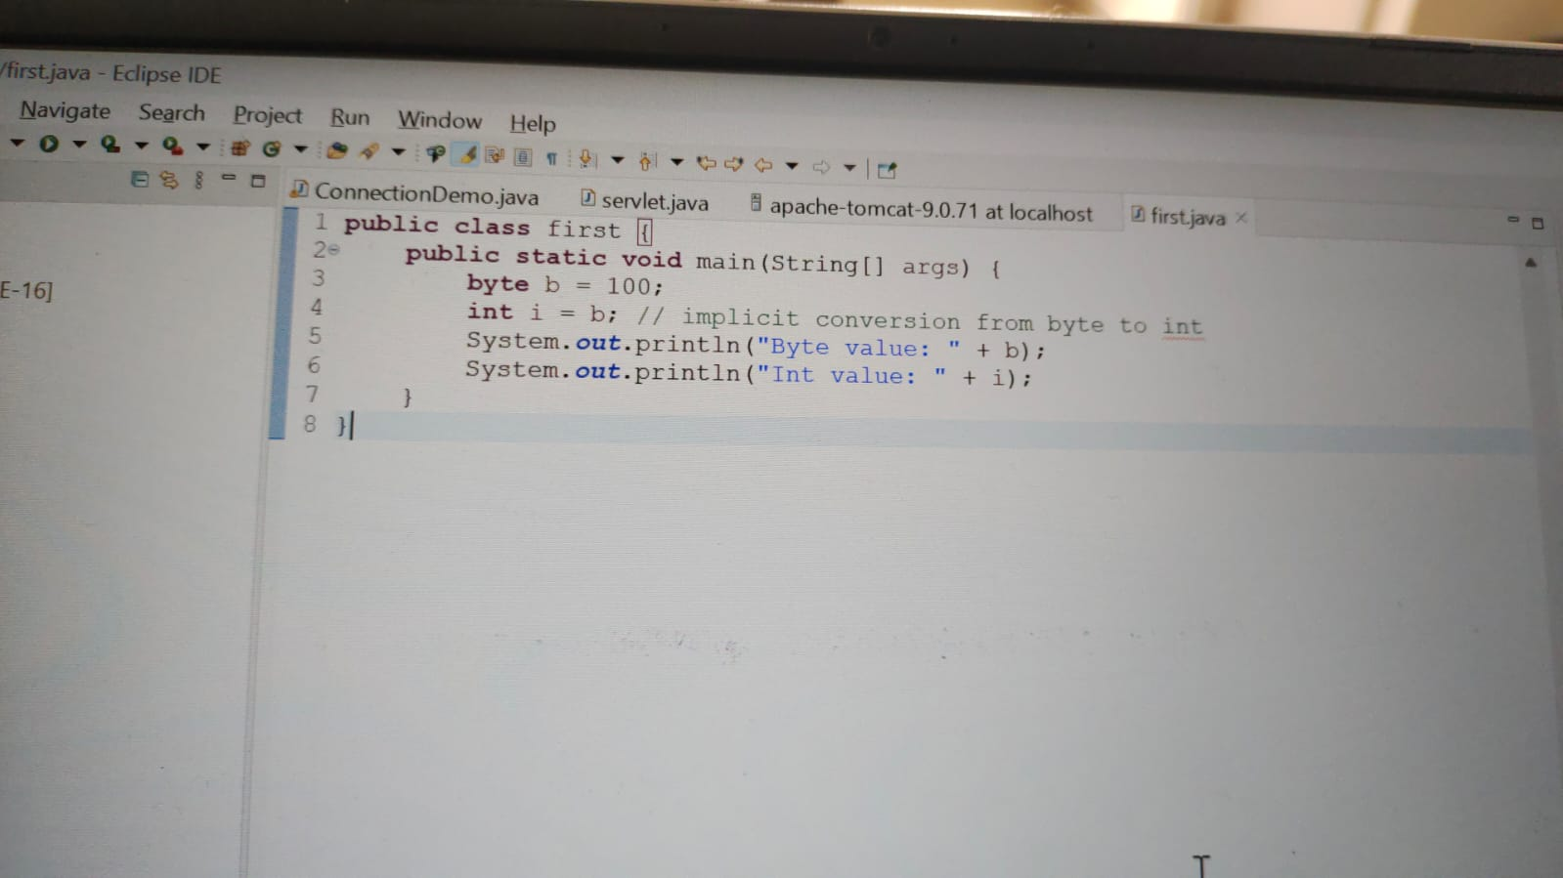

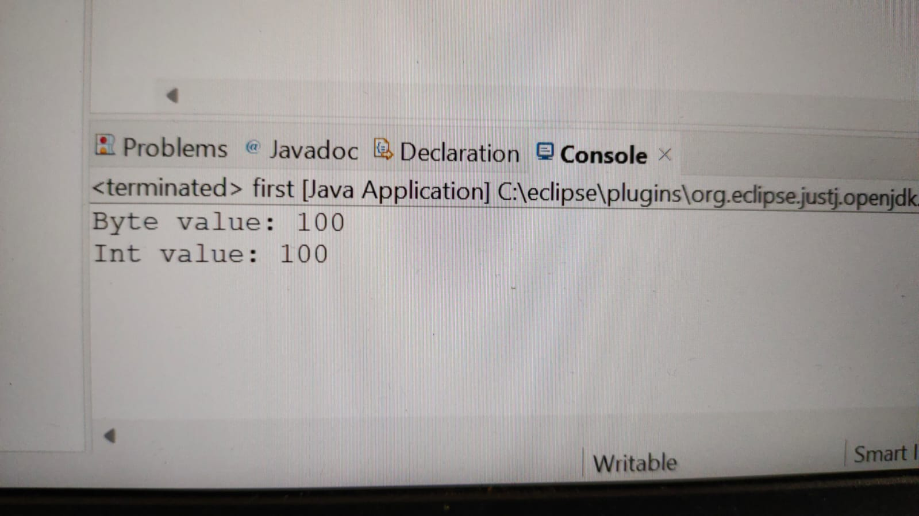

**IMPLICIT CONVERSION**

**BYTE TO LONG**

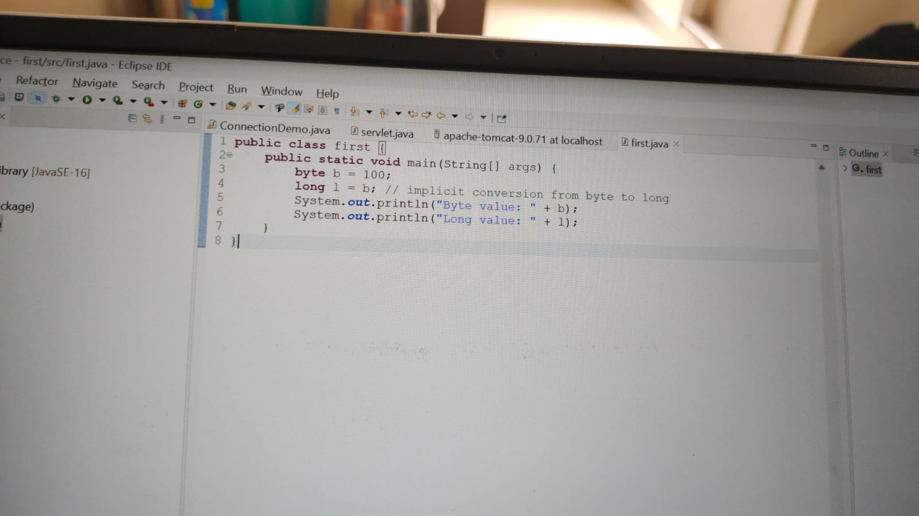

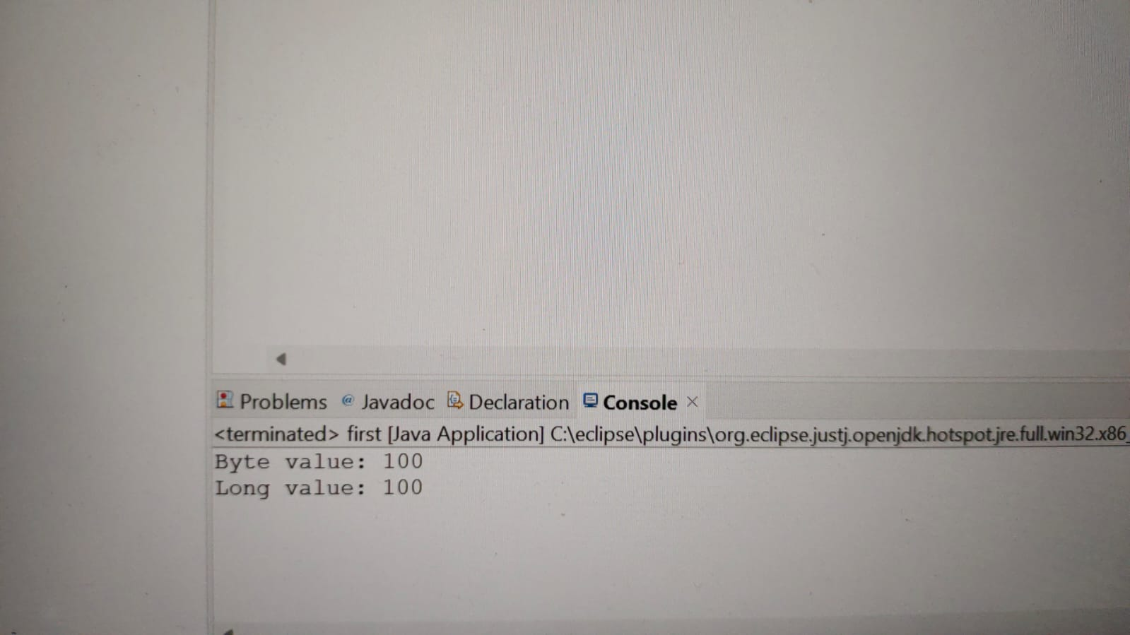

**IMPLICIT CONVERSION**

**BYTE TO FLOAT**

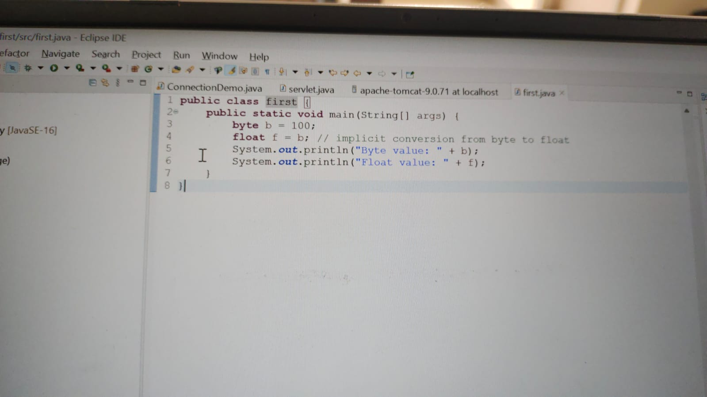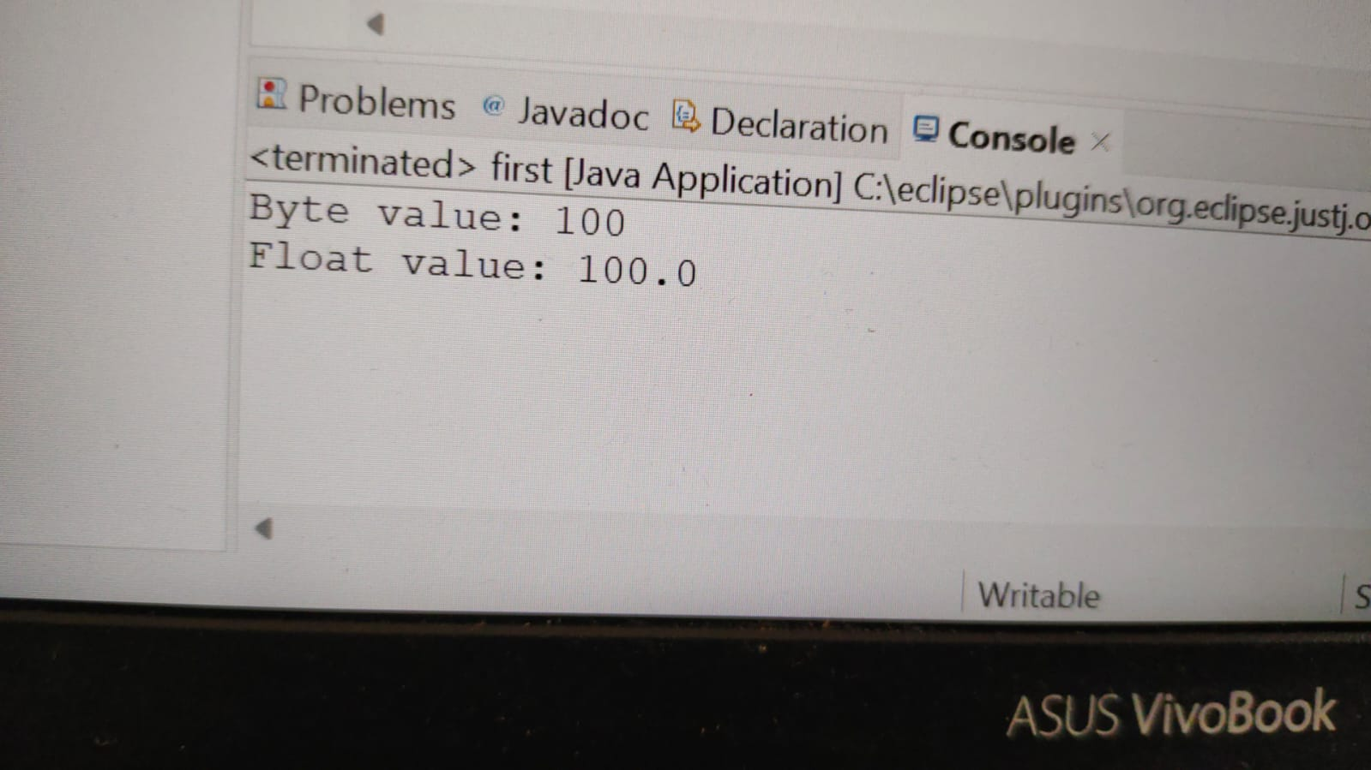

**IMPLICIT CONVERSION**

**BYTE TO DOUBLE**

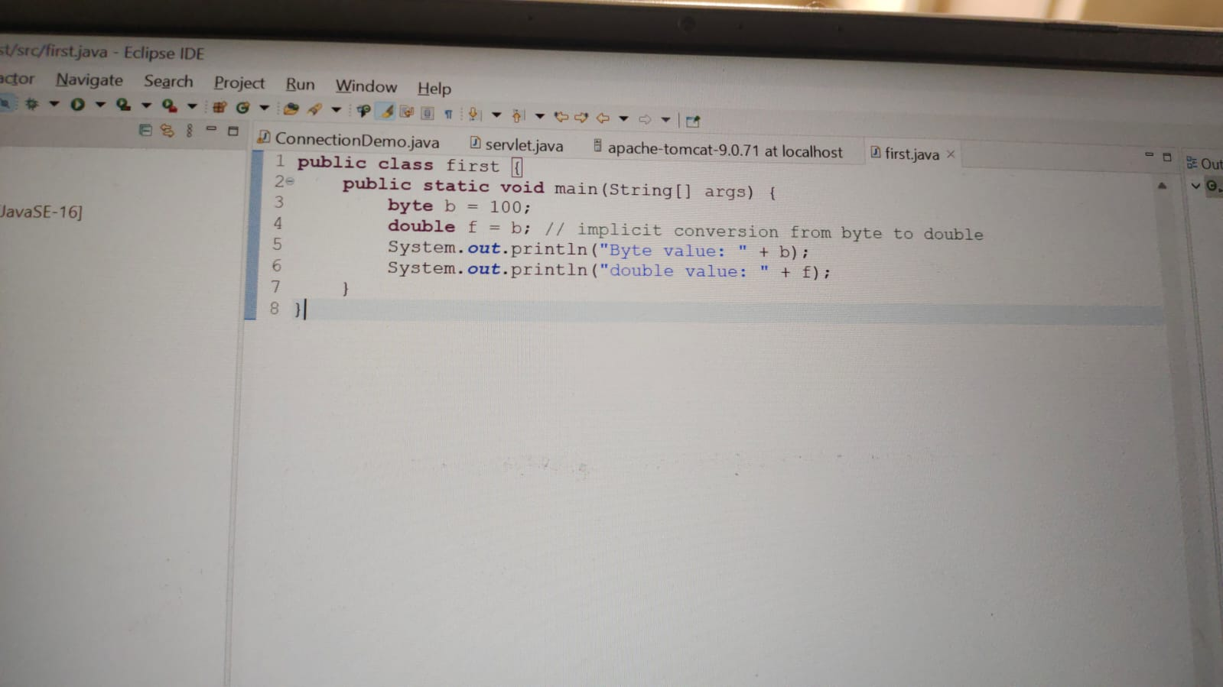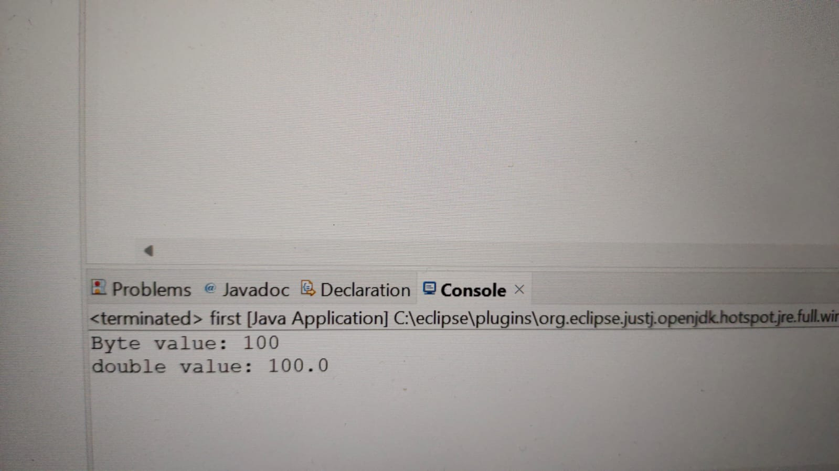

**IMPLICIT CONVERSION**

**BYTE TO CHARACTER**

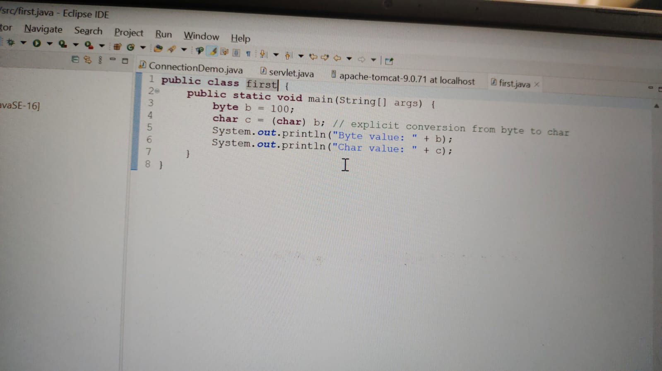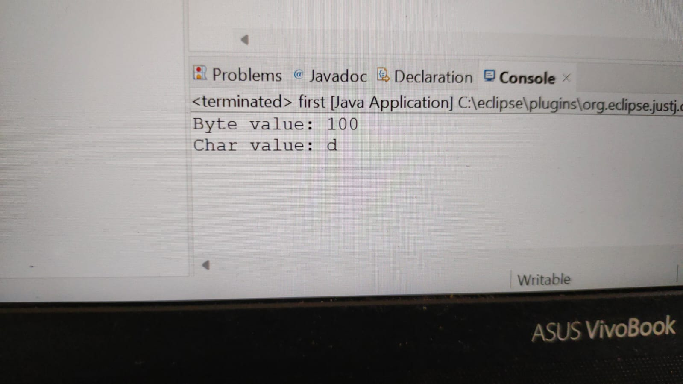

**EXPLICIT CONVERSION**

**BYTE TO BOOLEAN**

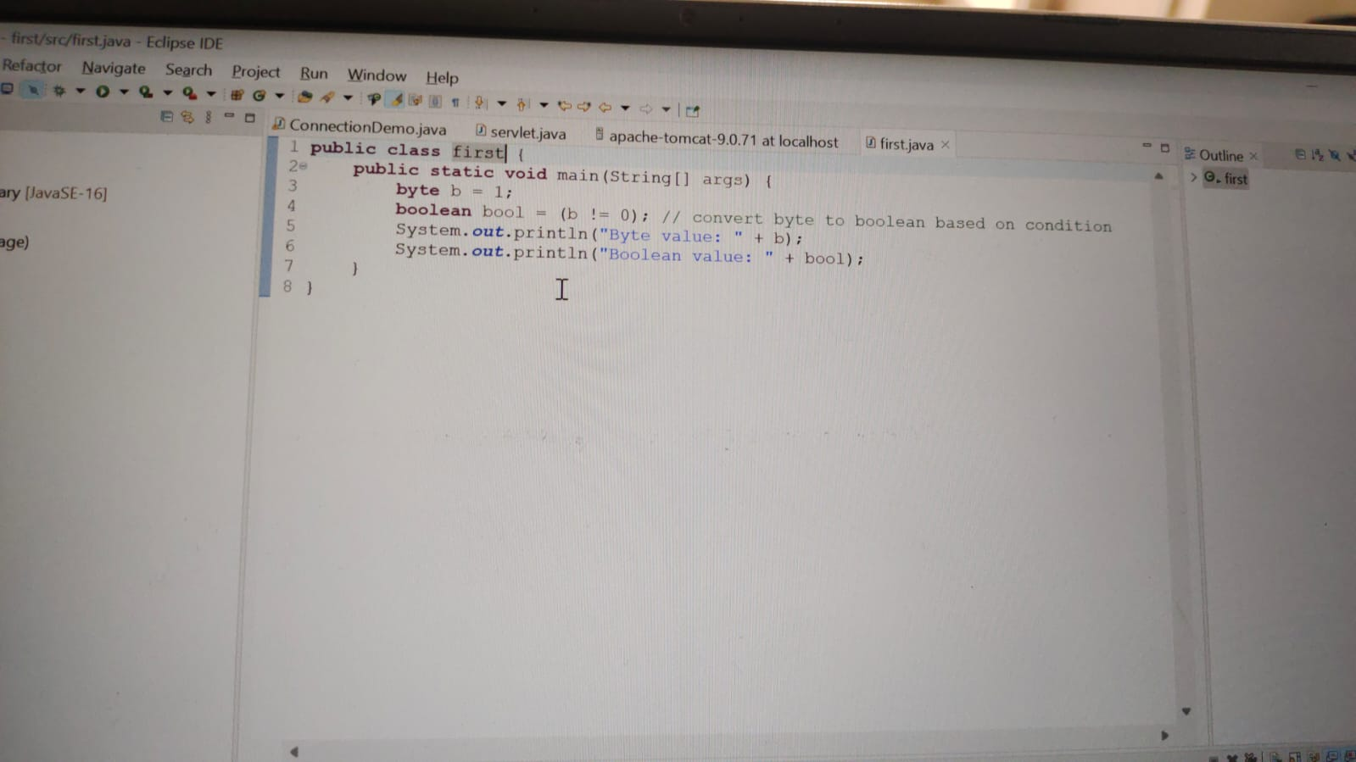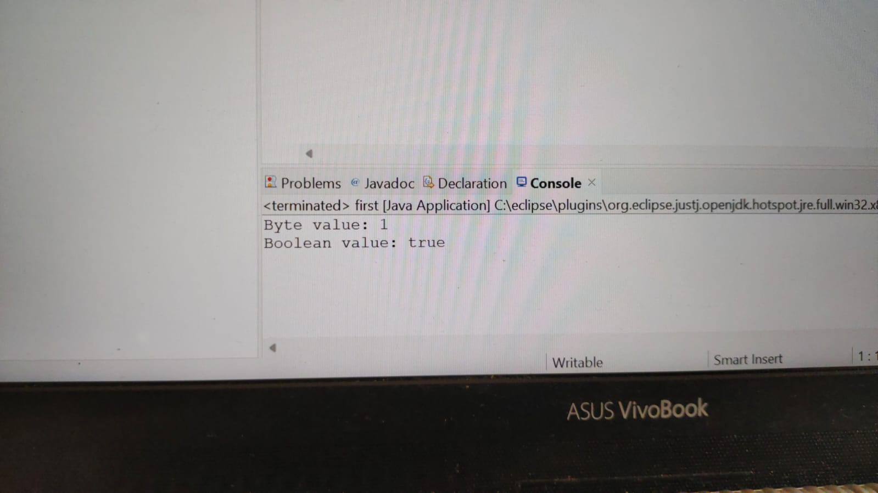

**EXPLICIT CONVERSION**

**SHORT TO BYTE**

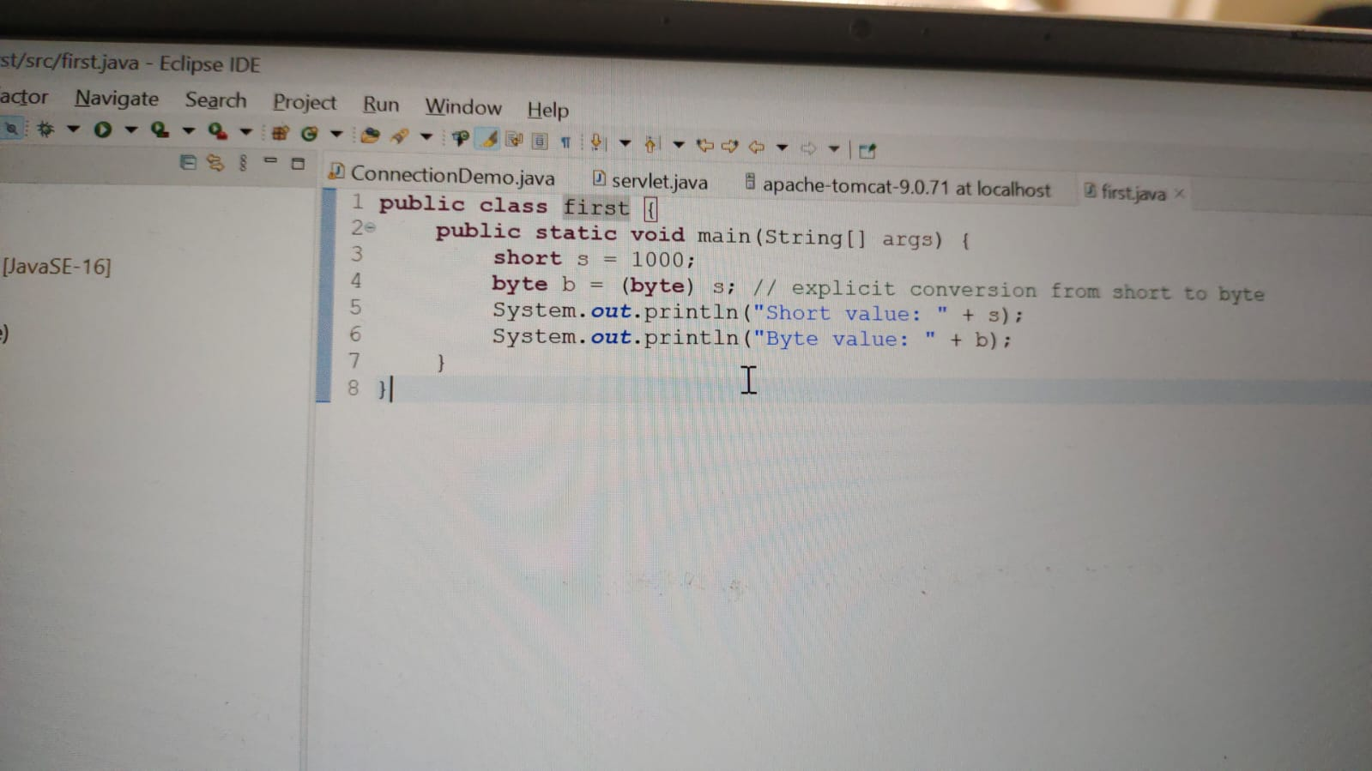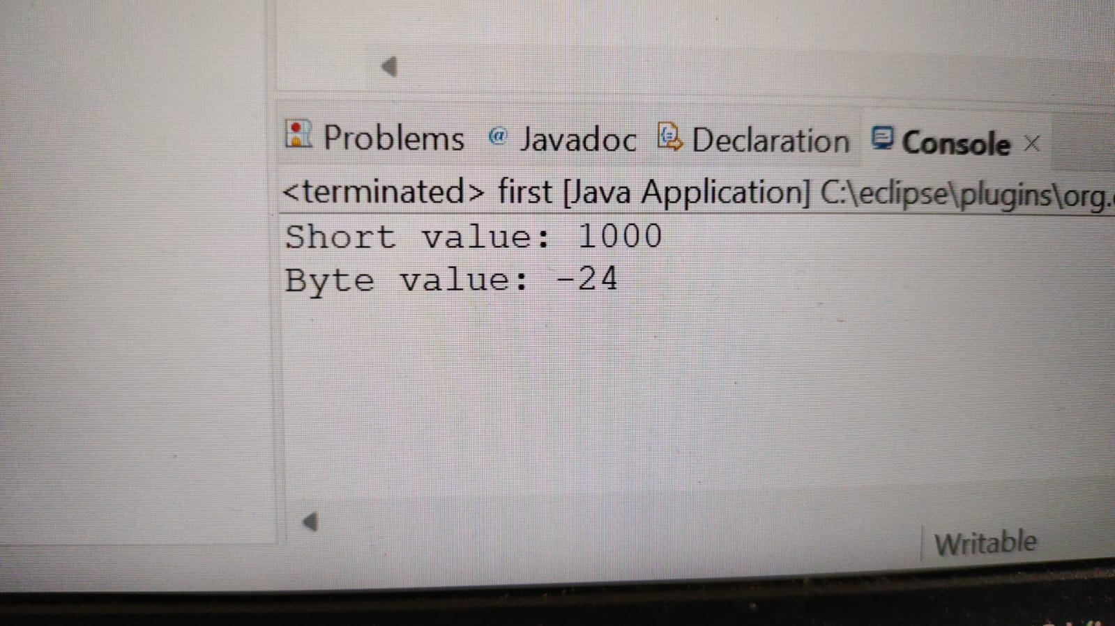

**EXPLICIT CONVERSION**

**SHORT TO INT**

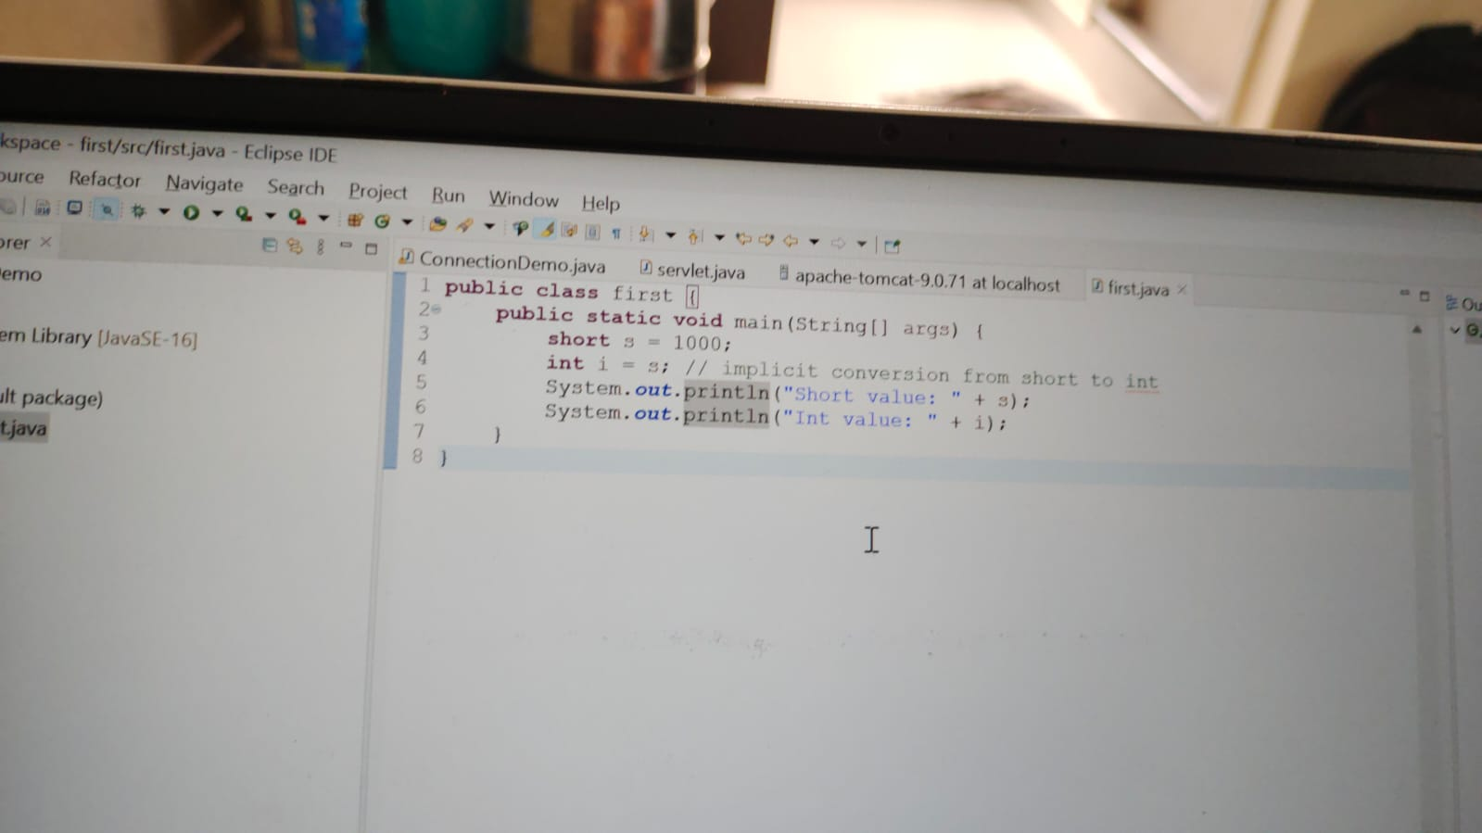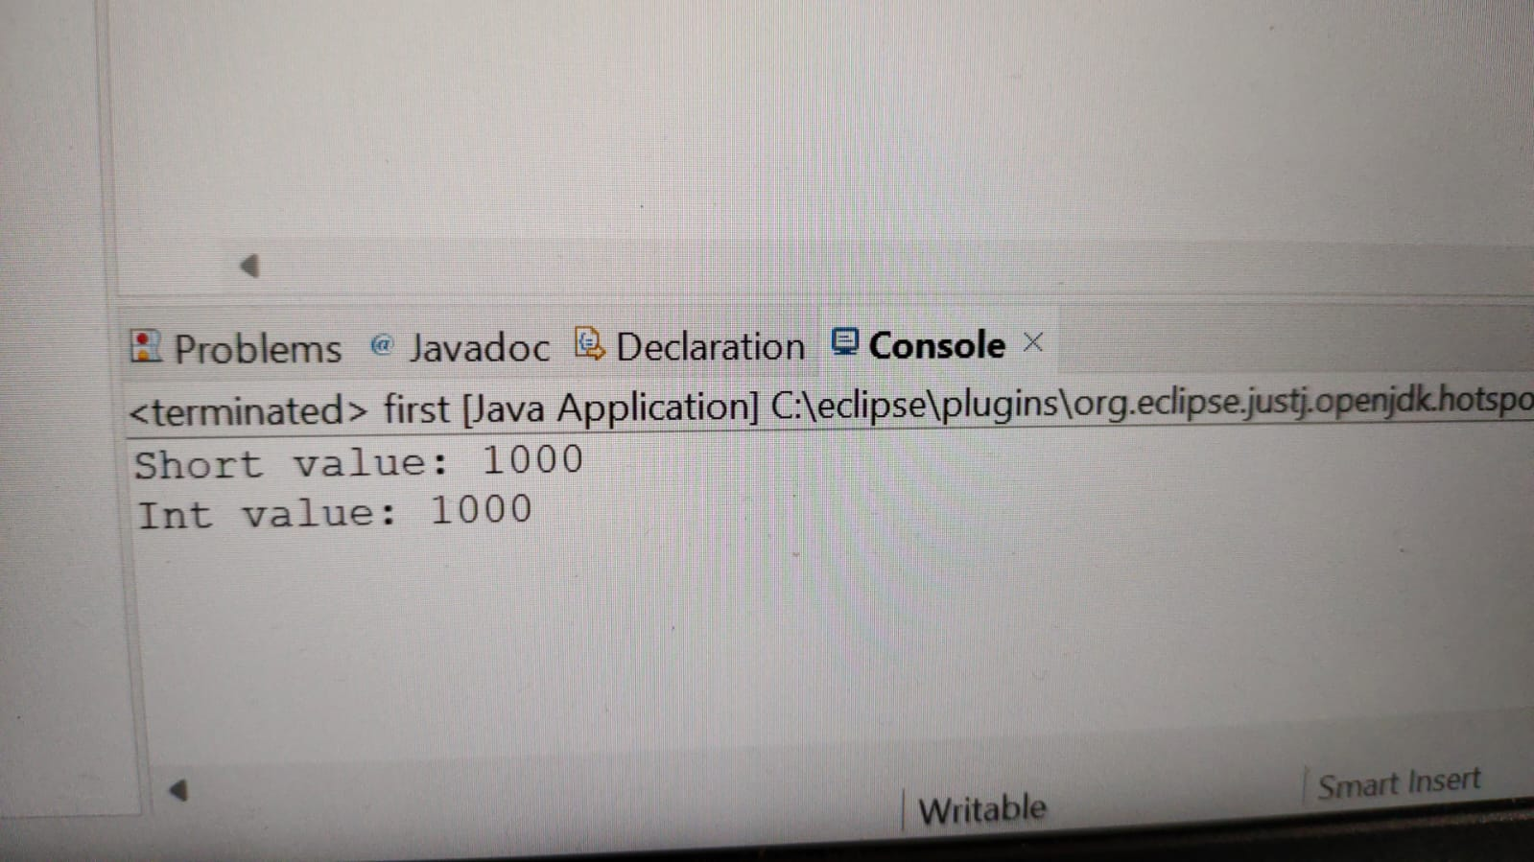

**IMPLICIT CONVERSION**

**SHORT TO LONG**

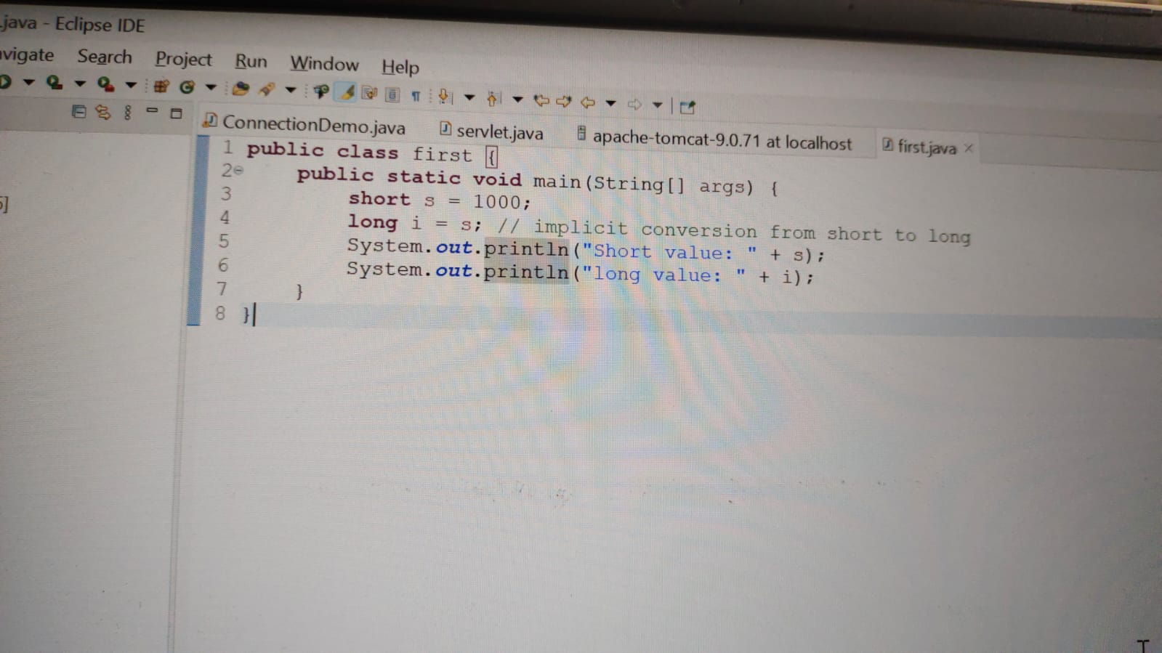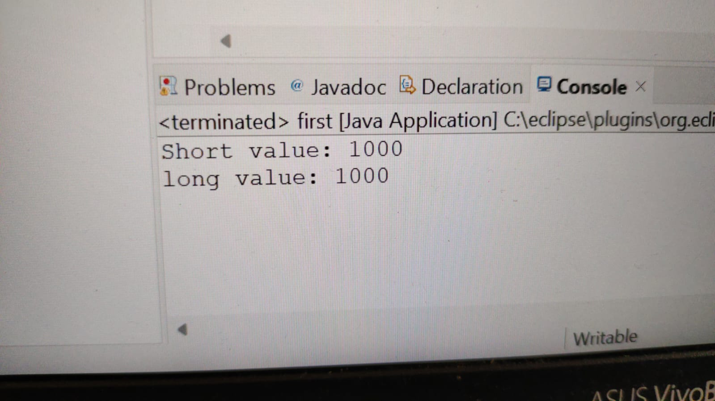

**IMPLICIT CONVERSION**

**SHORT TO FLOAT**

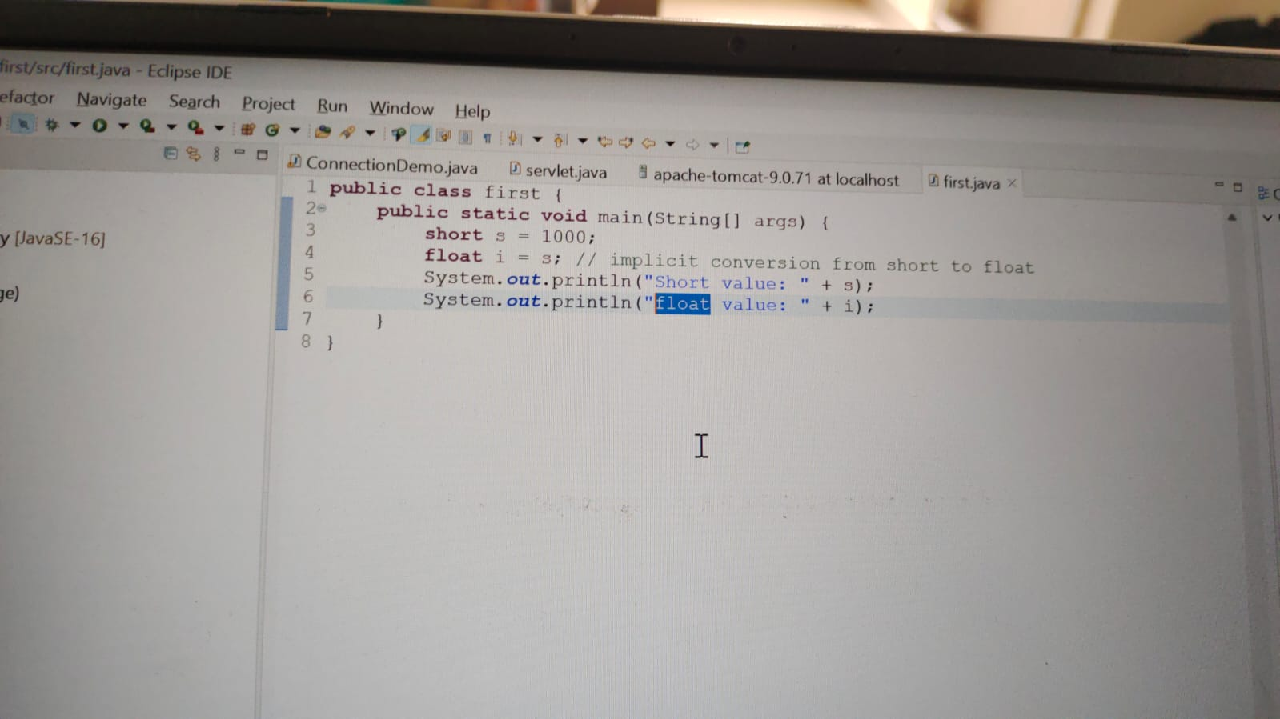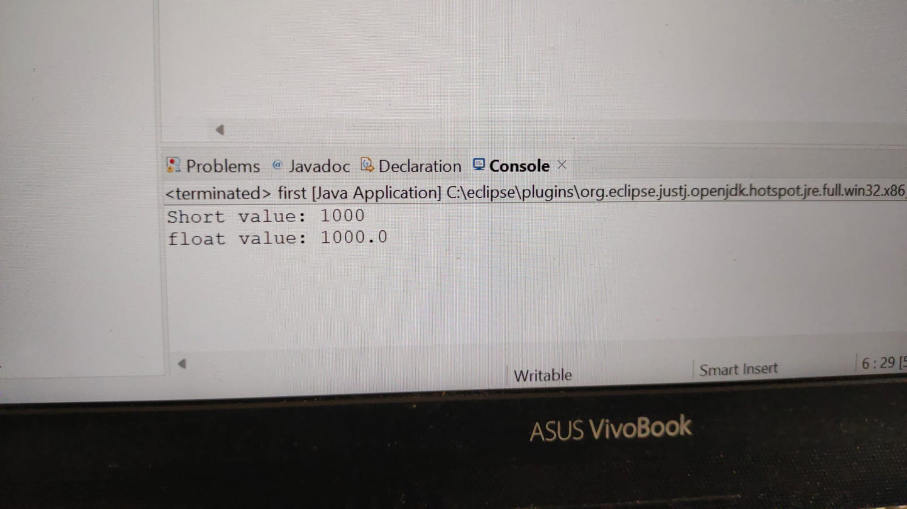

**IMPLICIT CONVERSION**

**SHORT TO DOUBLE**

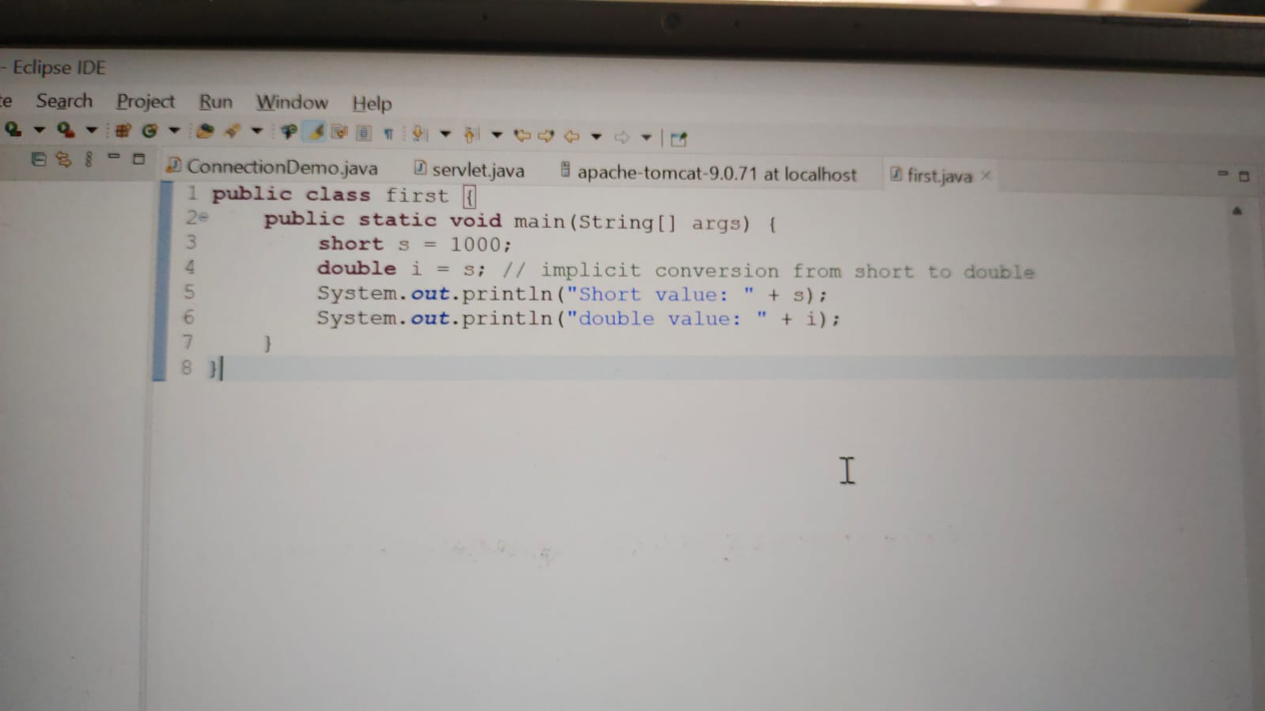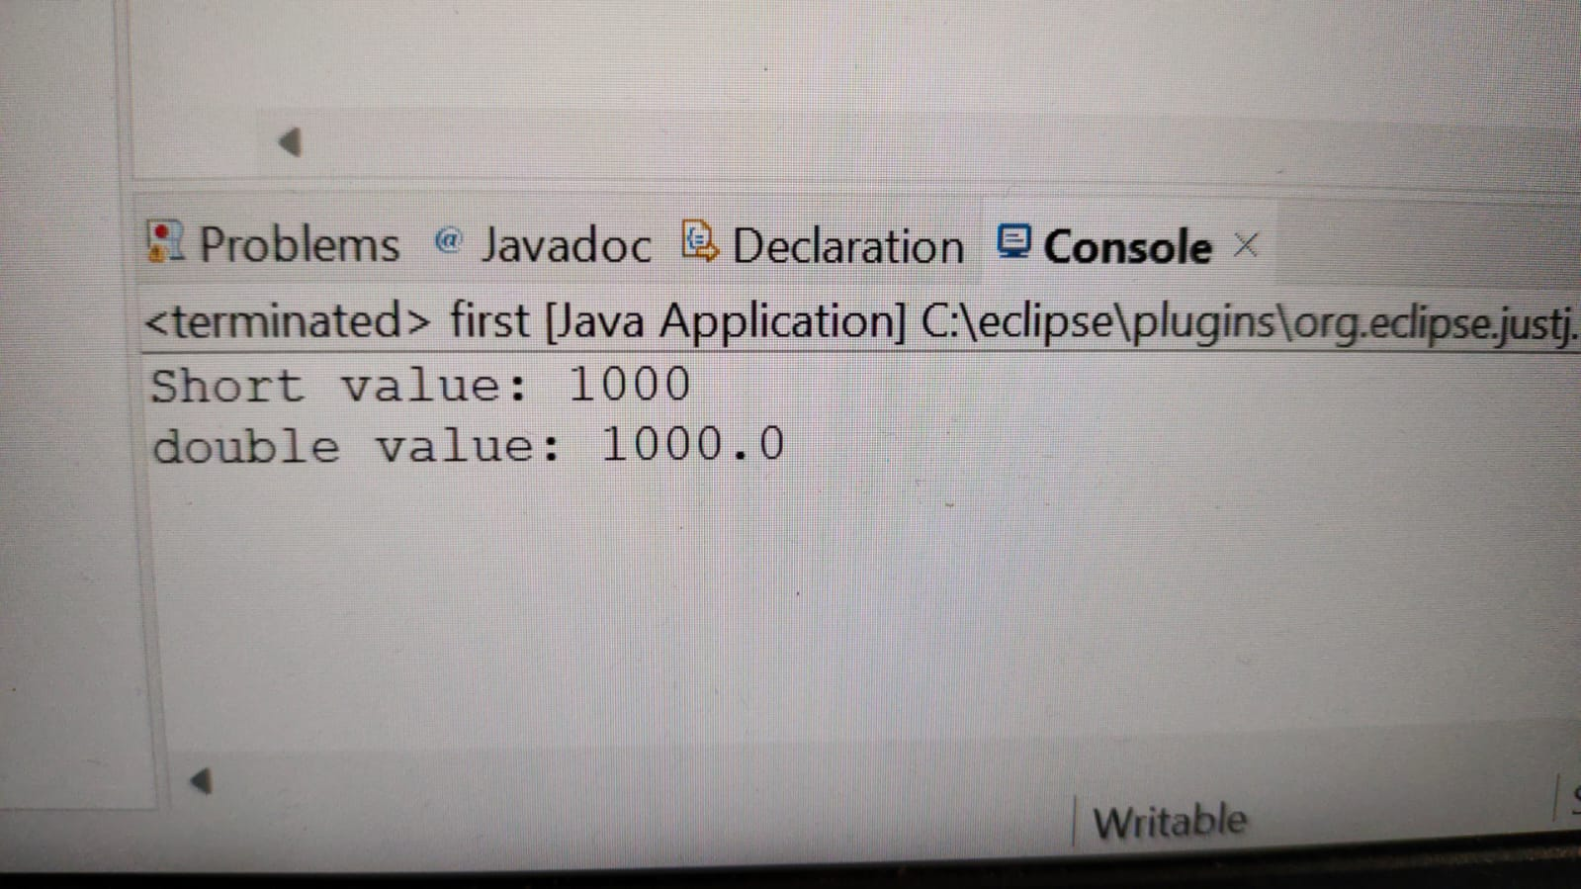

**IMPLICIT CONVERSION**

**SHORT TO CHARACTER**

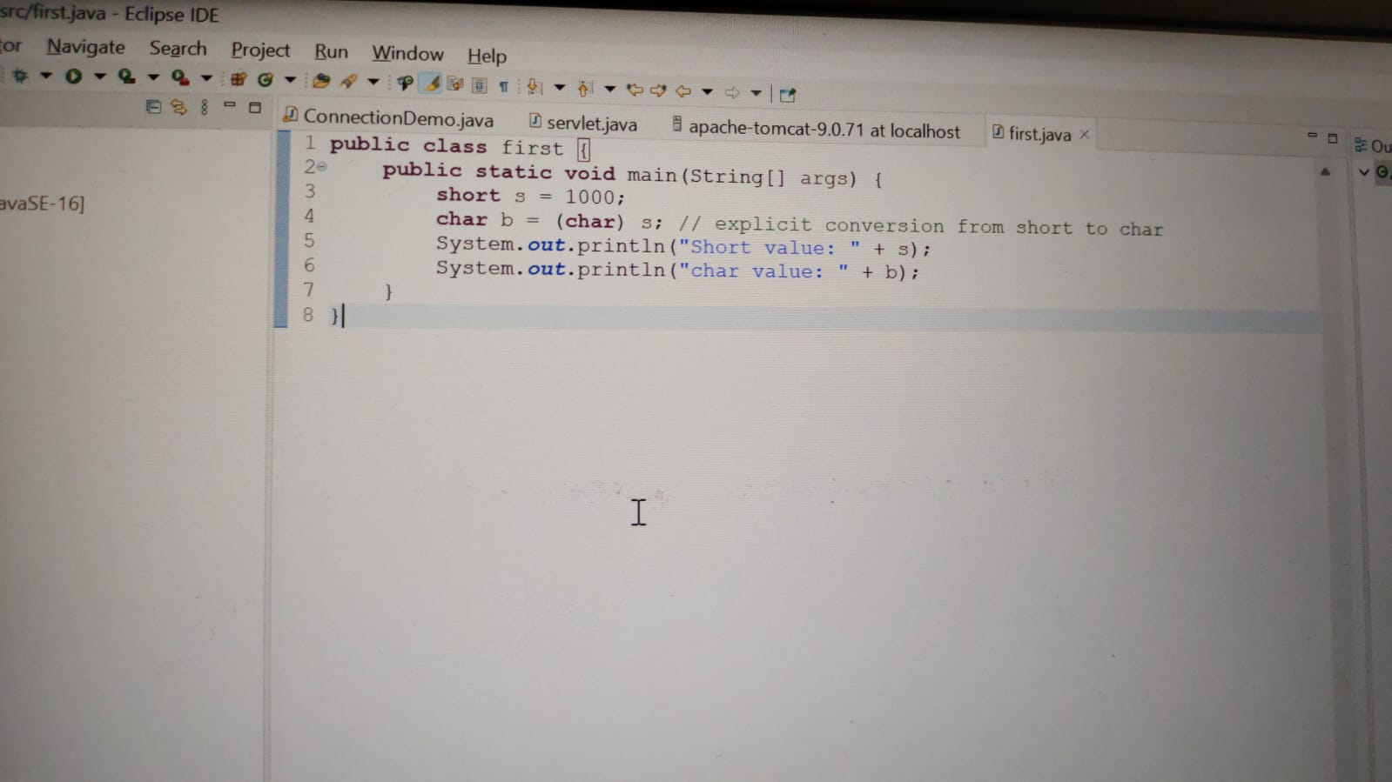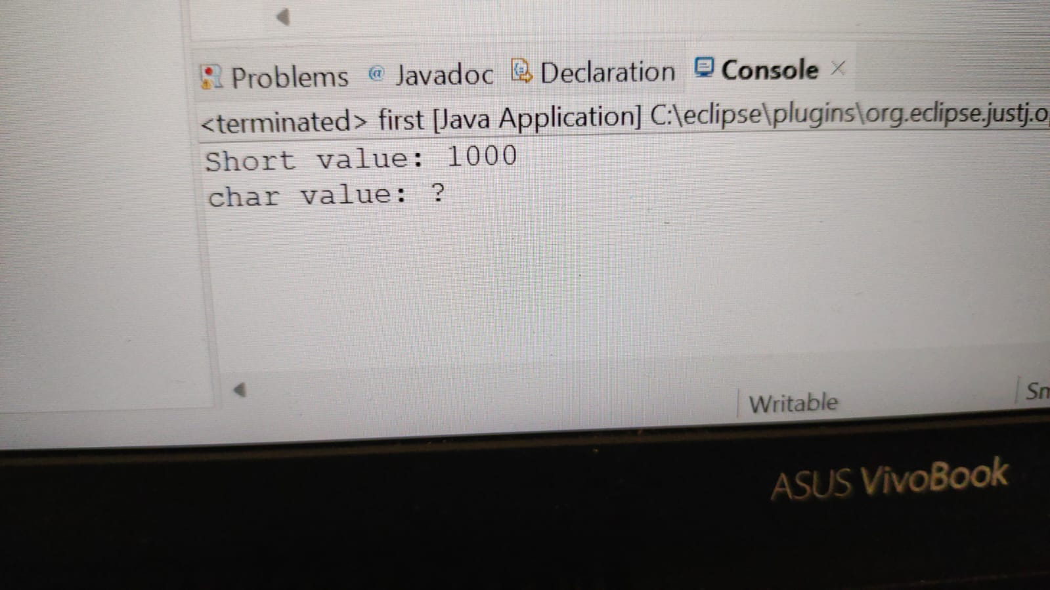

**EXPLICIT CONVERSION**

**SHORT TO BOOLEAN**

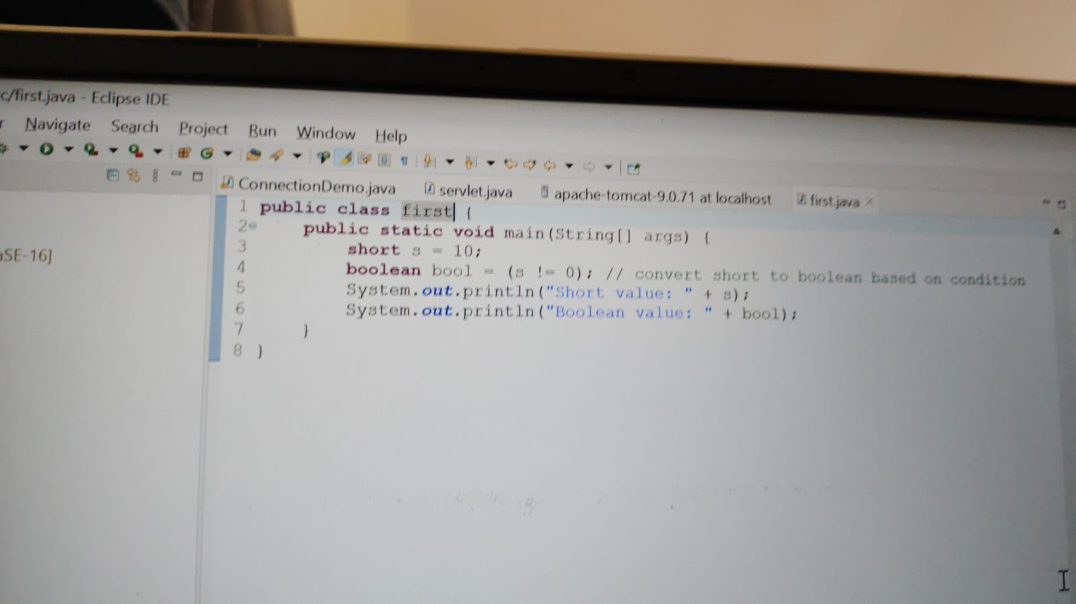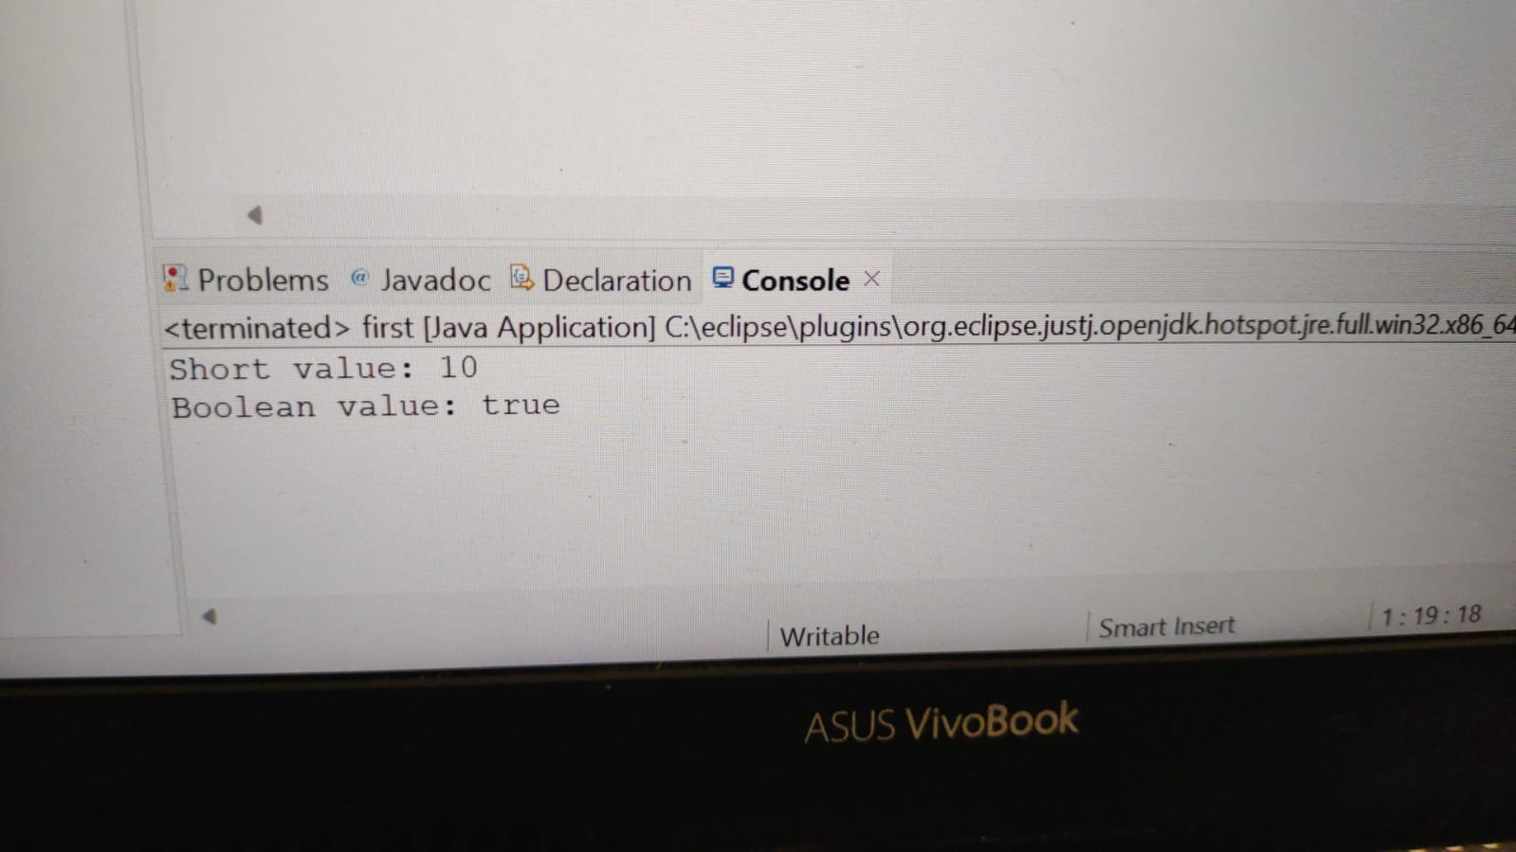

**EXPLICIT CONVERSION**

**INT TO BYTE**

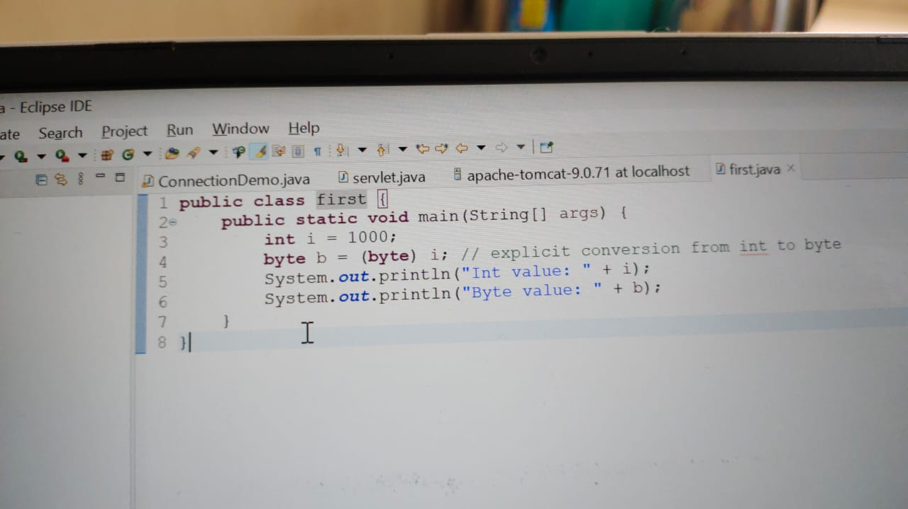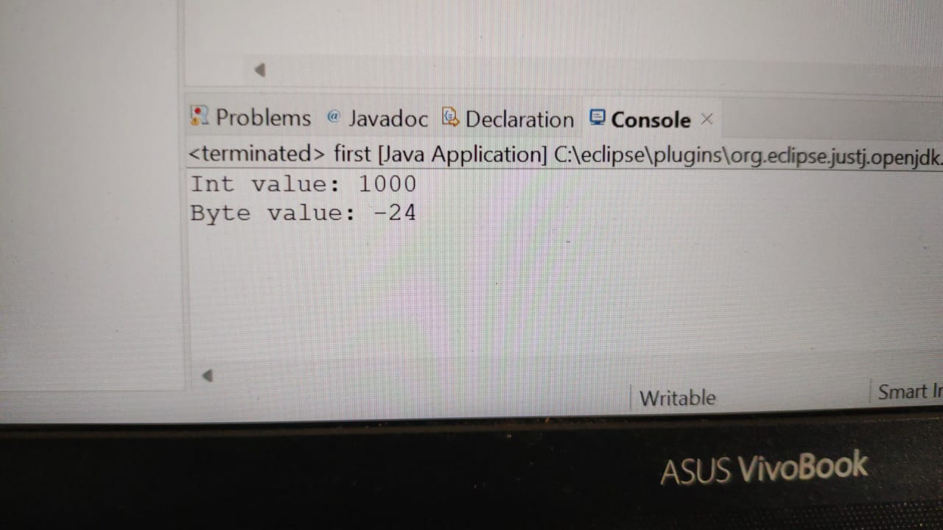

**EXPLICIT CONVERSION**

**INT TO SHORT**

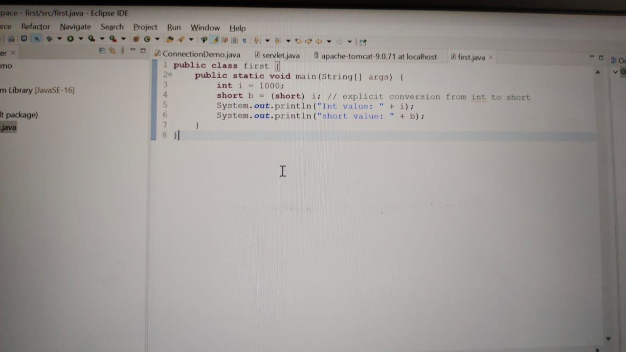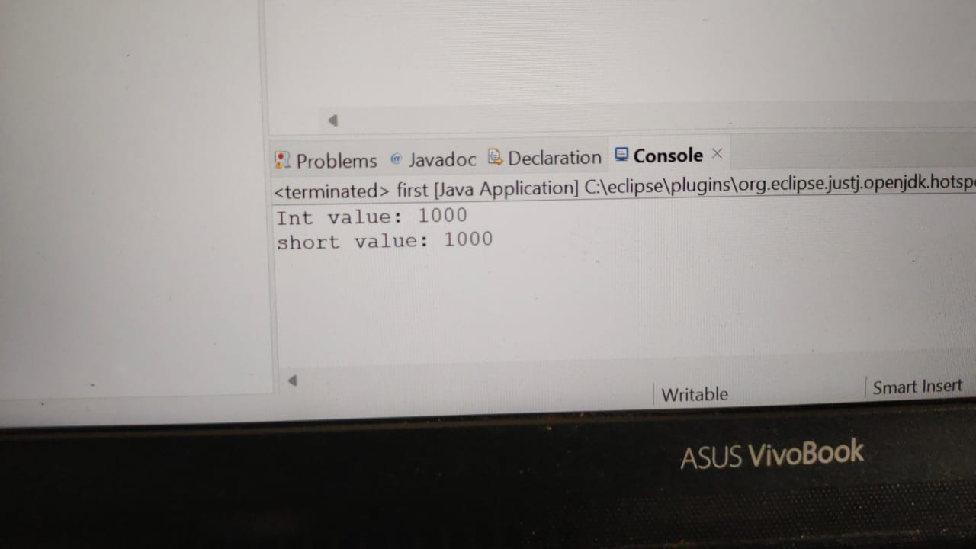

**EXPLICIT CONVERSION**

**INT TO LONG**

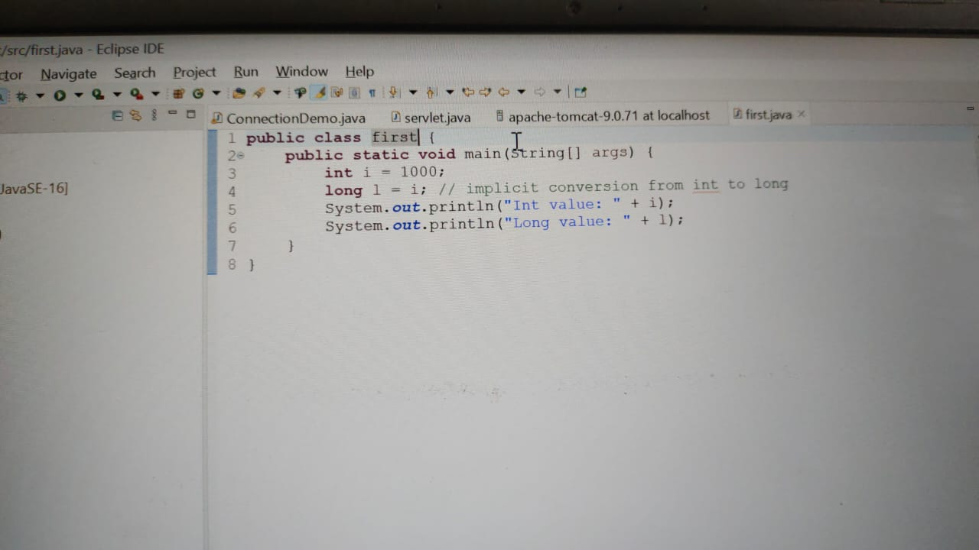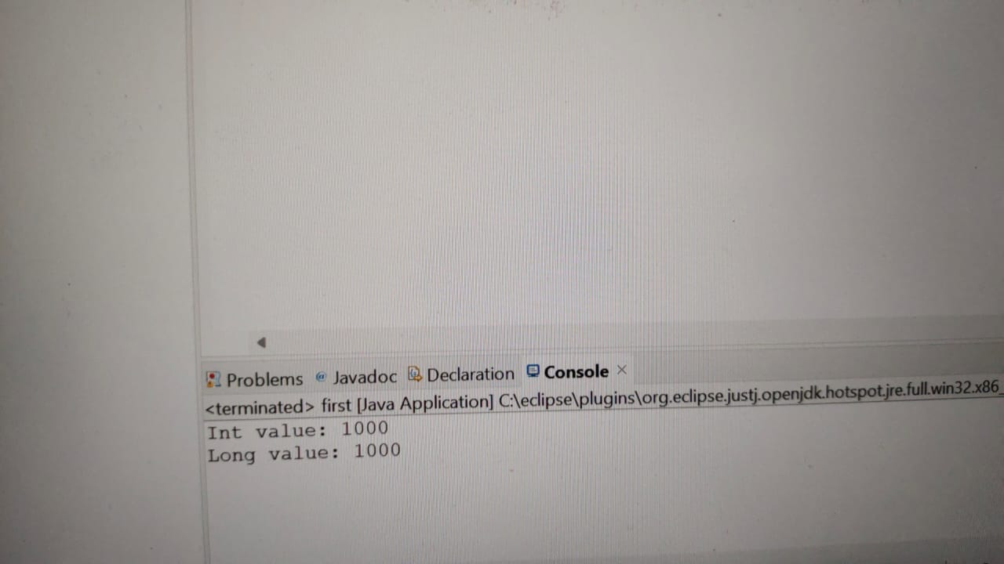

**IMPLICIT CONVERSION**

**INT TO FLOAT**

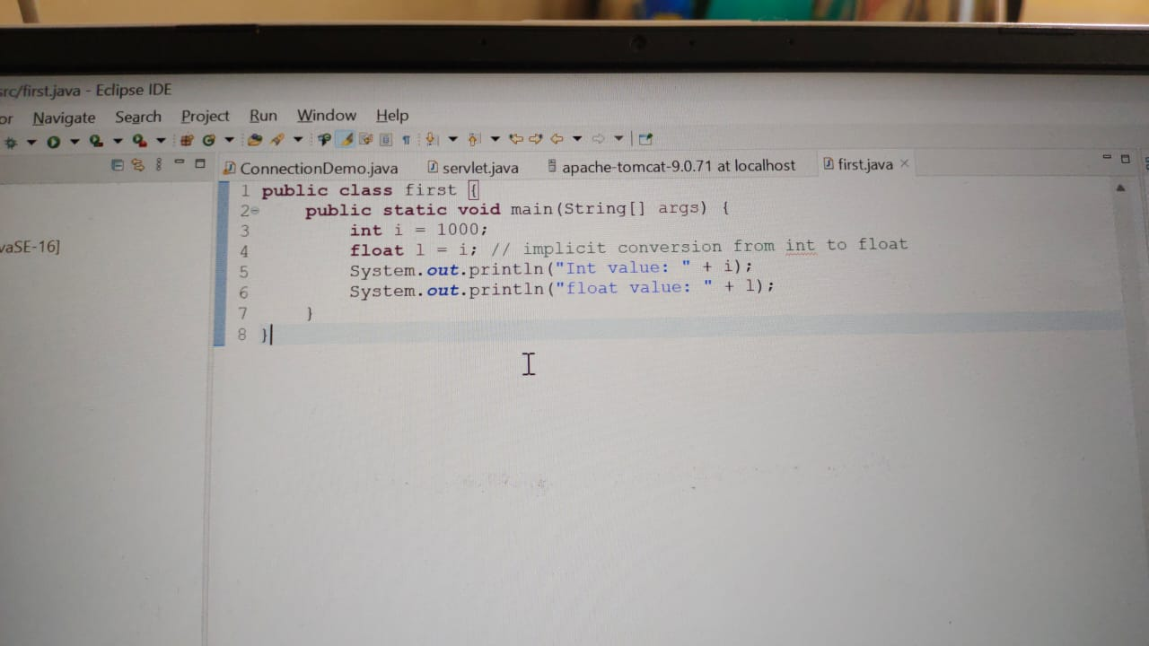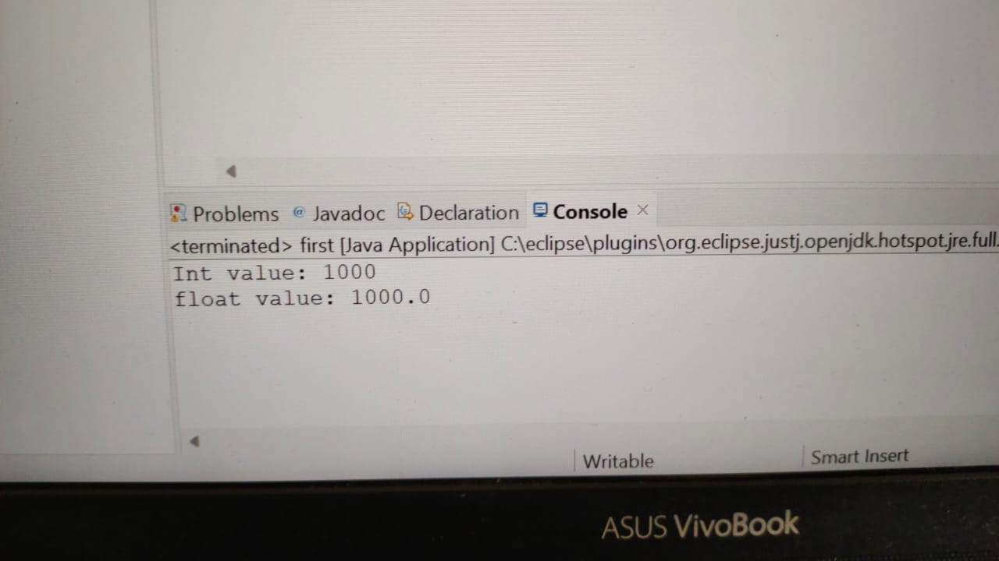

**IMPLICIT CONVERSION**

**INT TO DOUBLE**

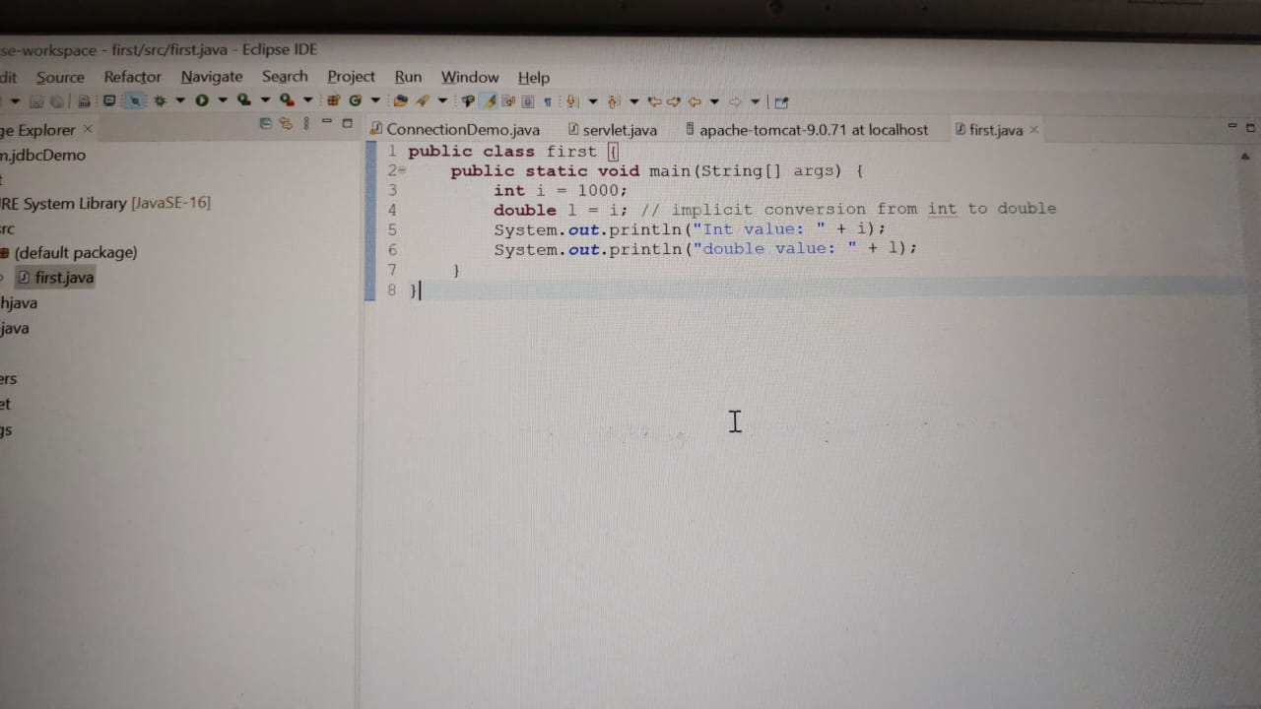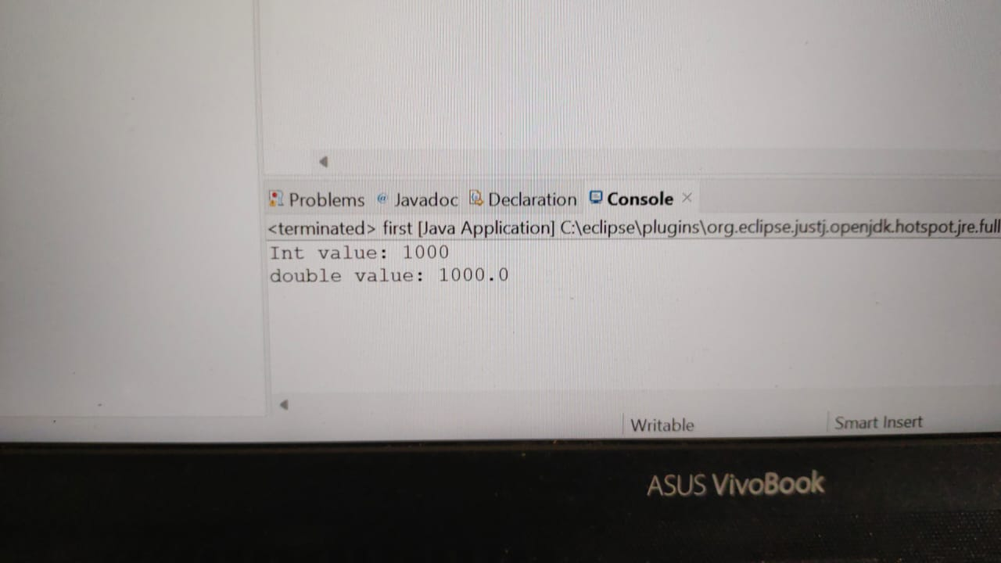

**IMPLICIT CONVERSION**

**INT TO CHARACTER**

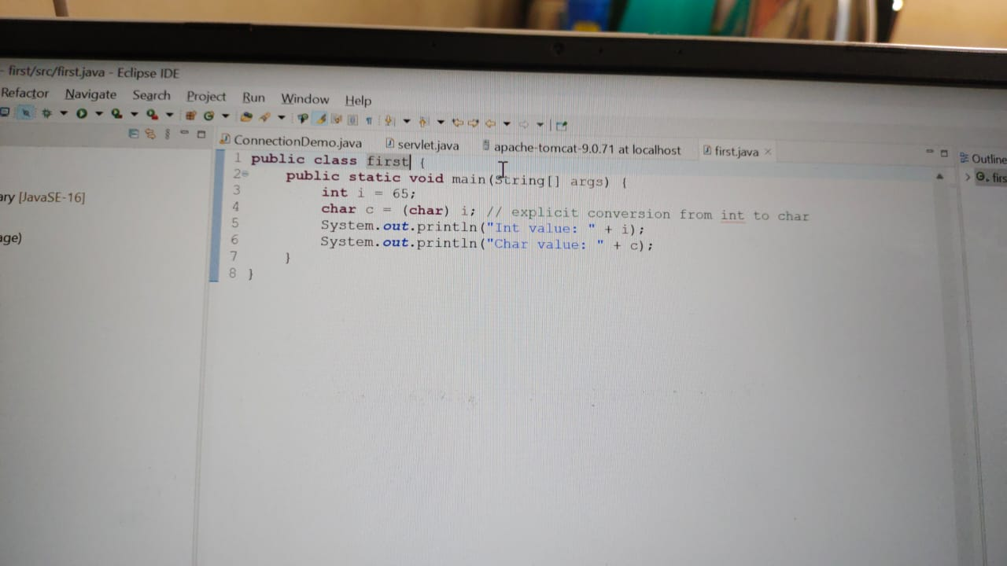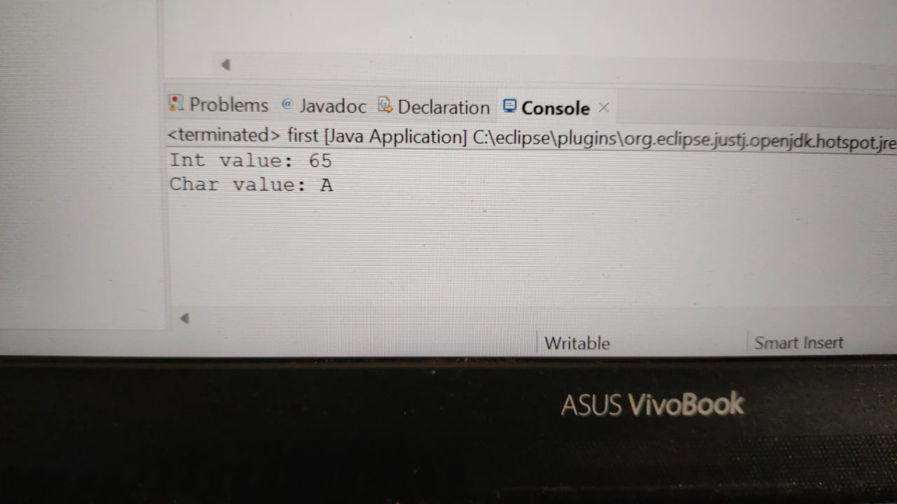

**EXPLICIT CONVERSION**

**INT TO BOOLEAN**

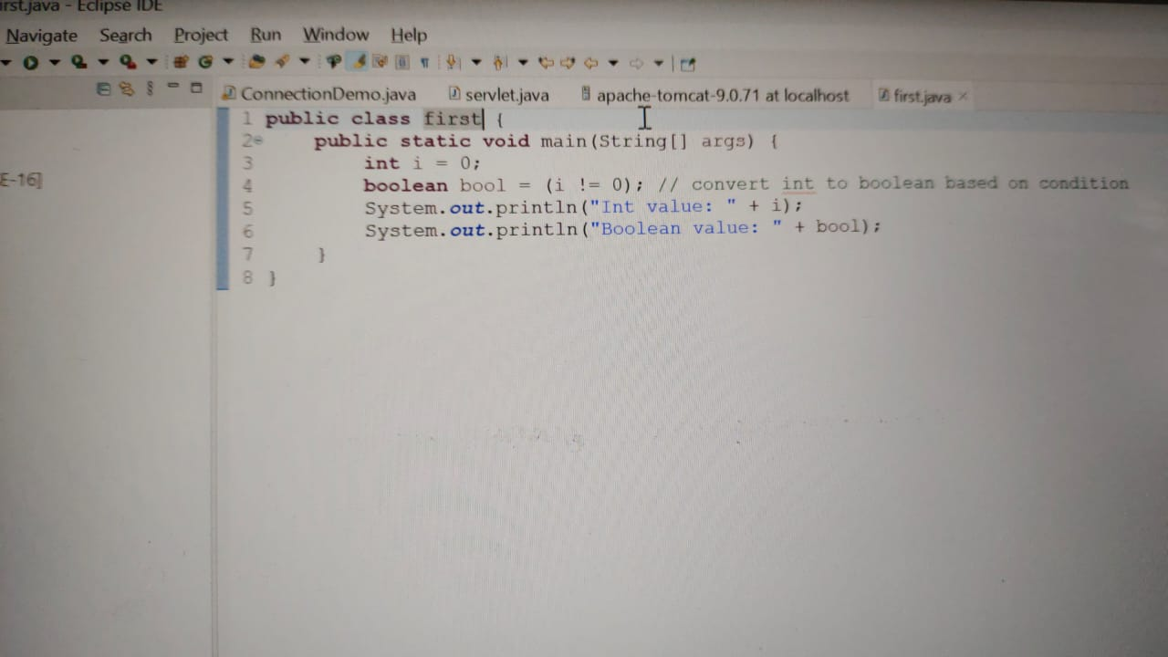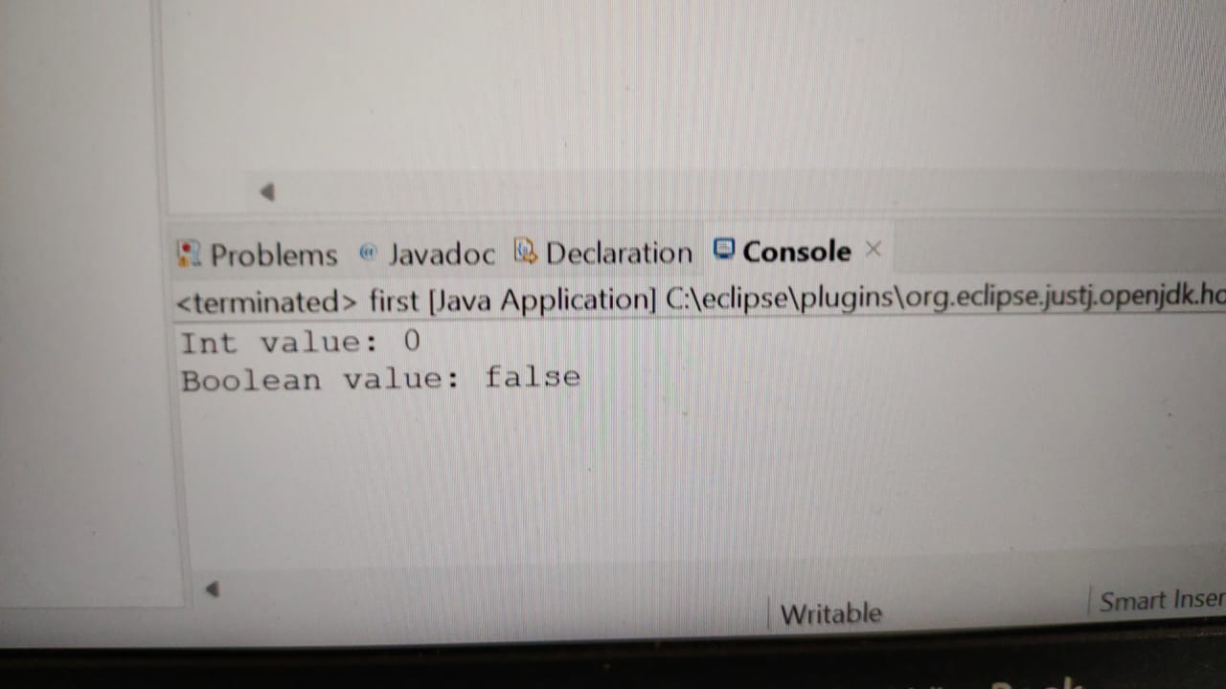

**EXPLICIT CONVERSION**

**LONG TO BYTE**

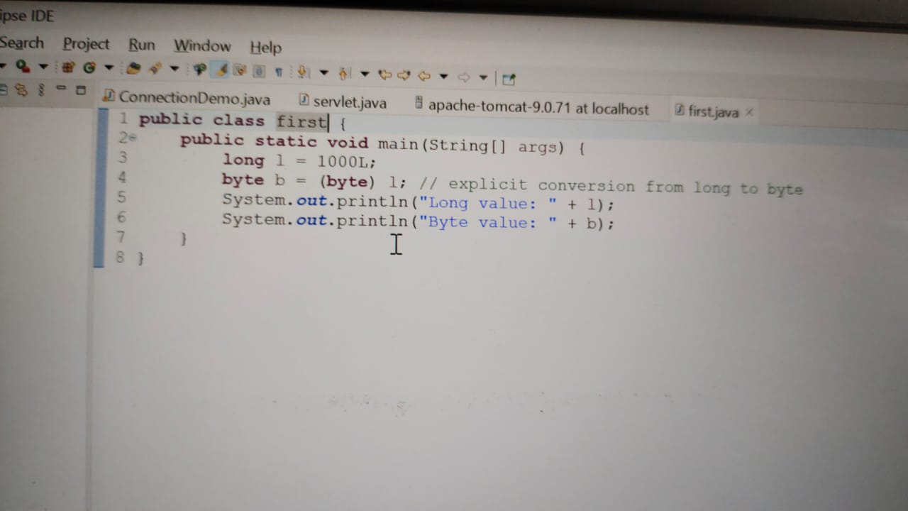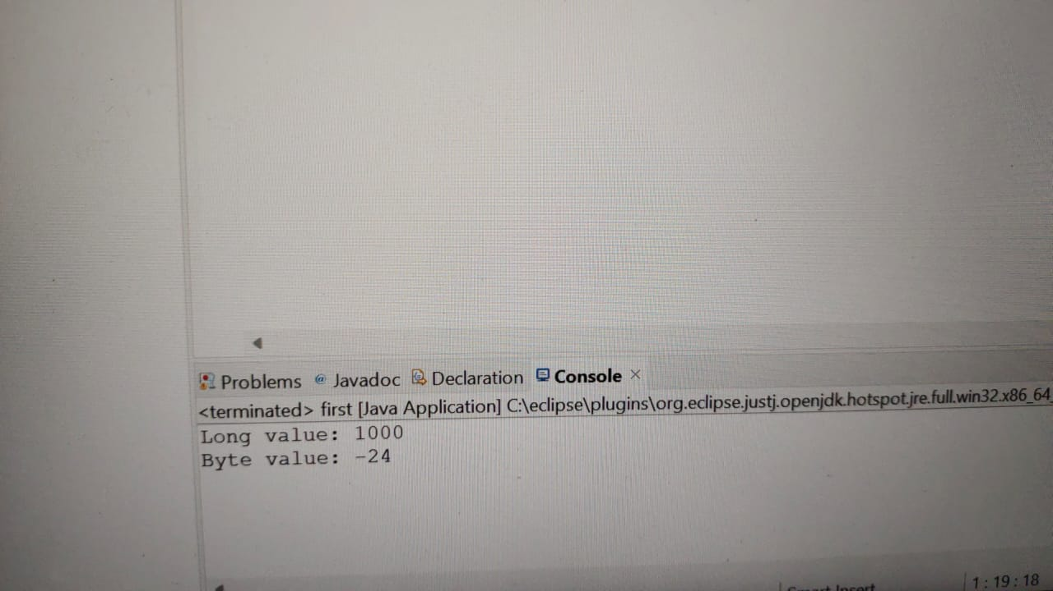

**EXPLICIT CONVERSION**

**LONG TO SHORT**

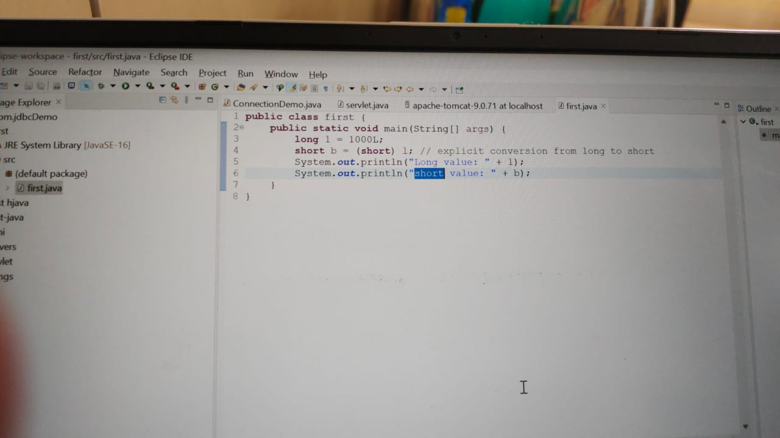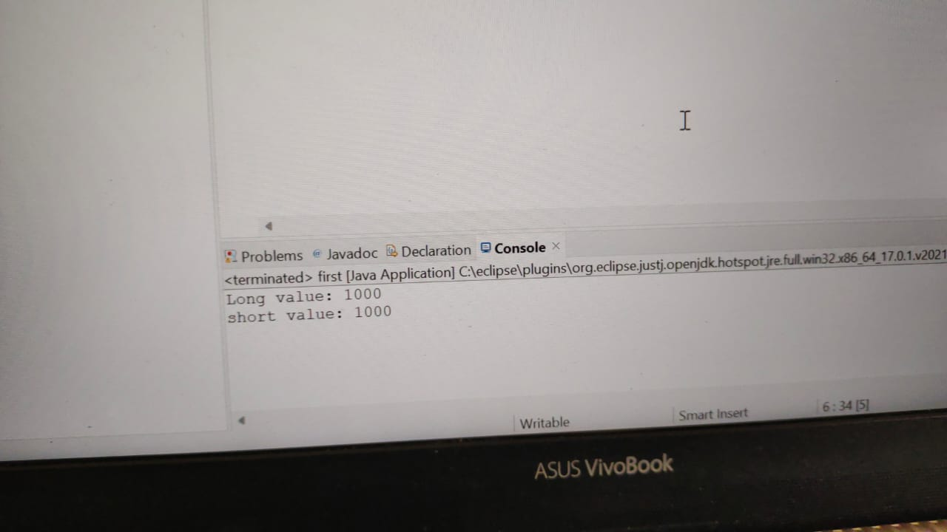

**EXPLICIT CONVERSION**

**LONG TO INT**

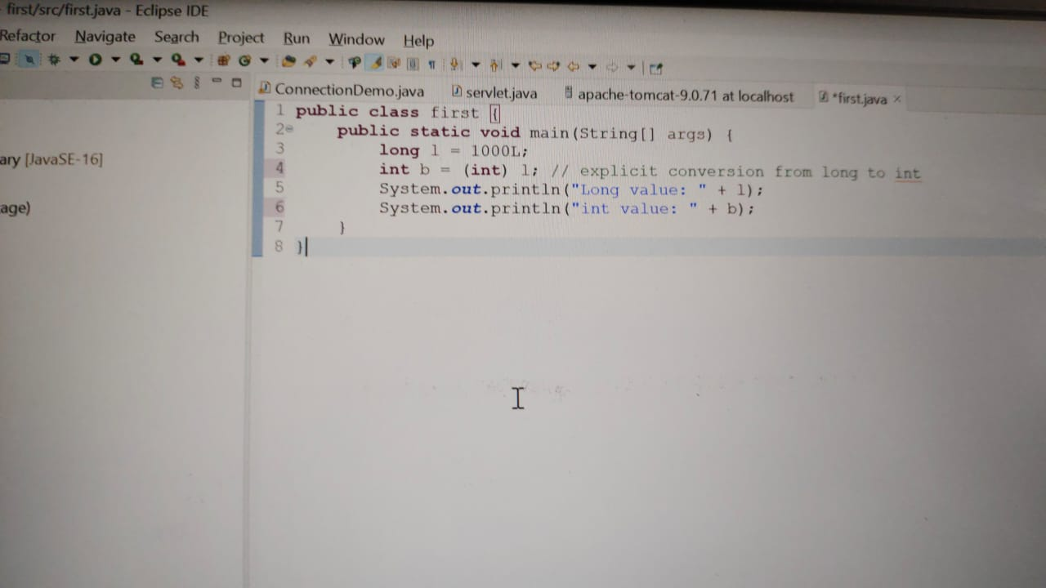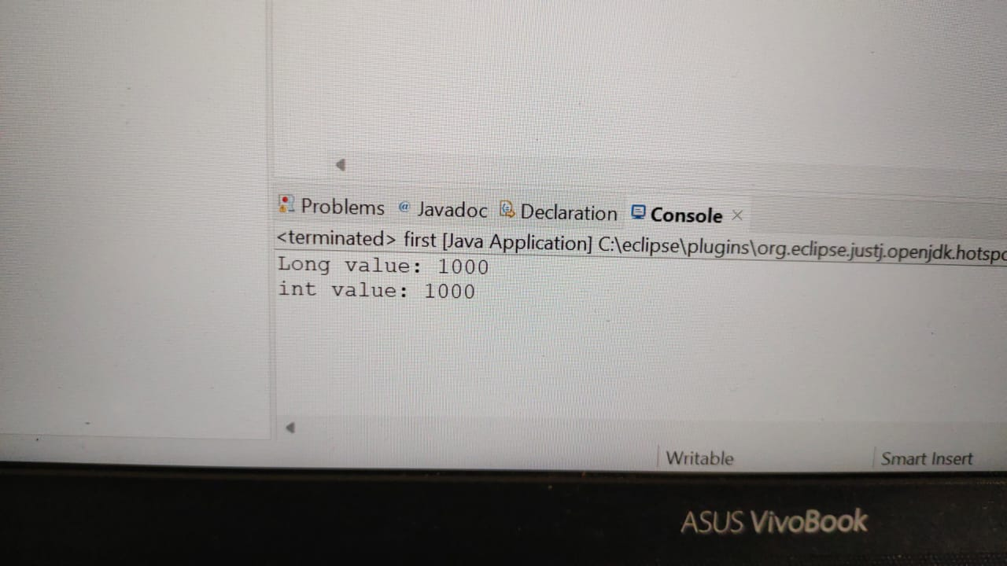

**EXPLICIT CONVERSION**

**LONG TO FLOAT**

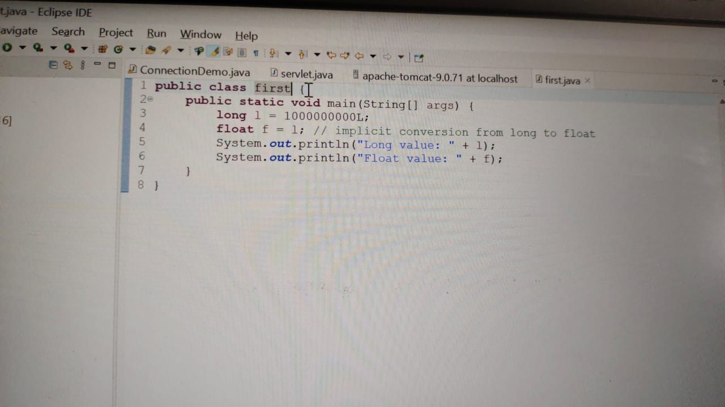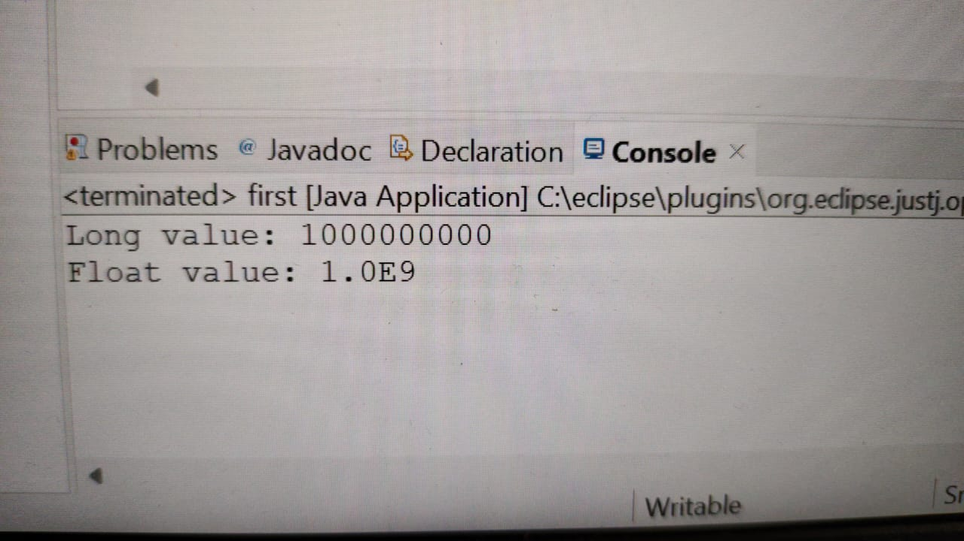

**IMPLICIT CONVERSION**

**LONG TO DOUBLE**

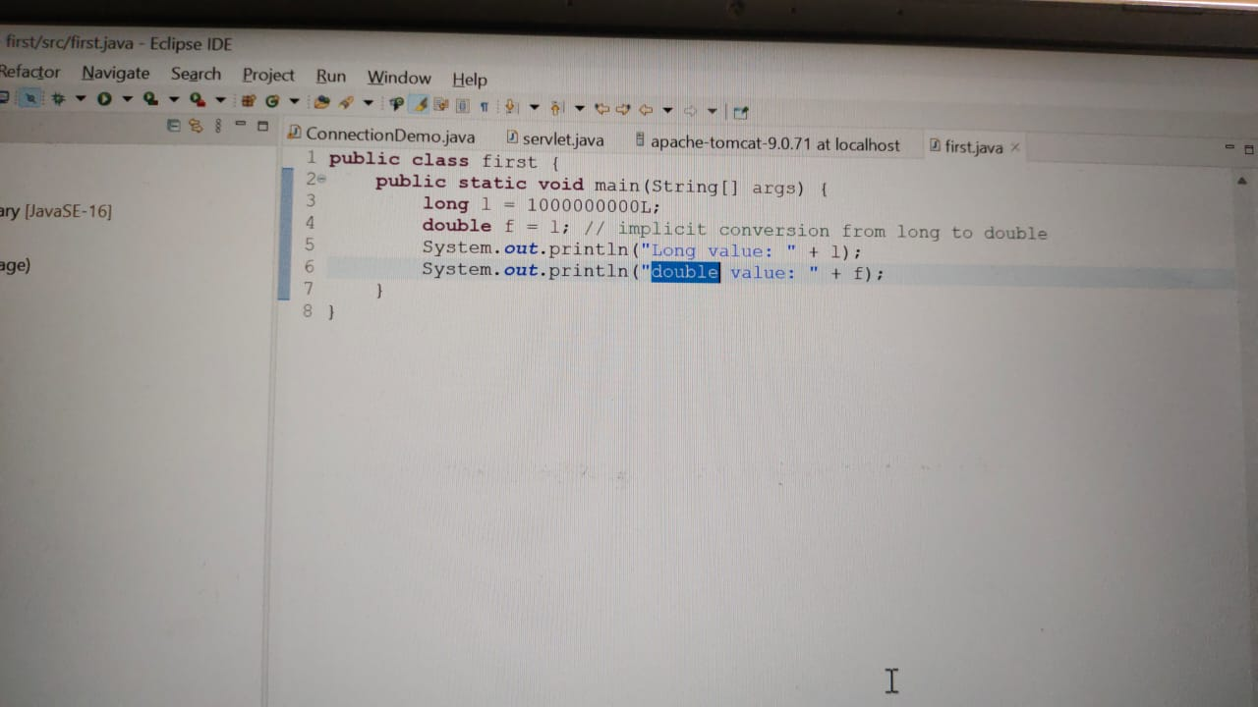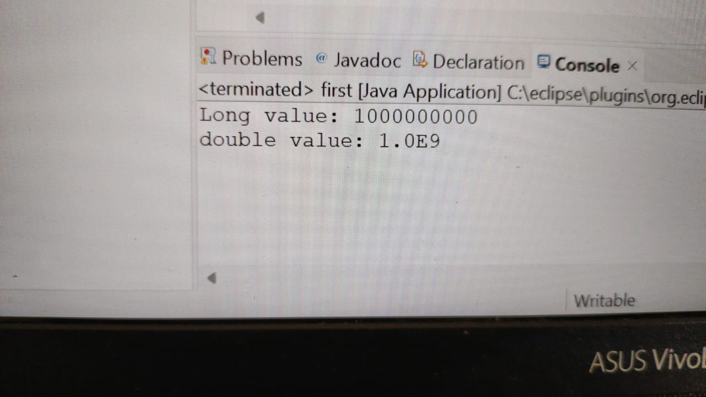

**IMPLICIT CONVERSION**

**LONG TO CHARACTER**

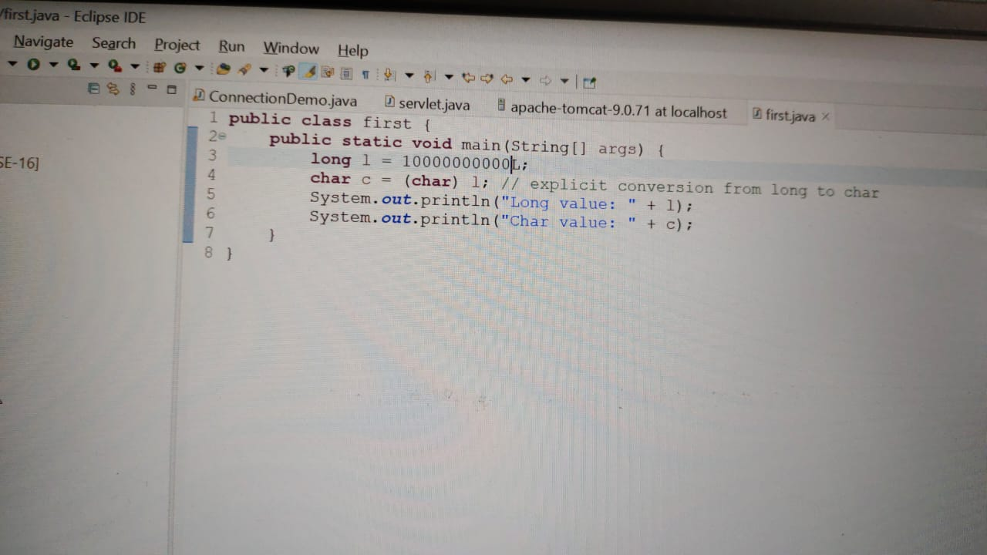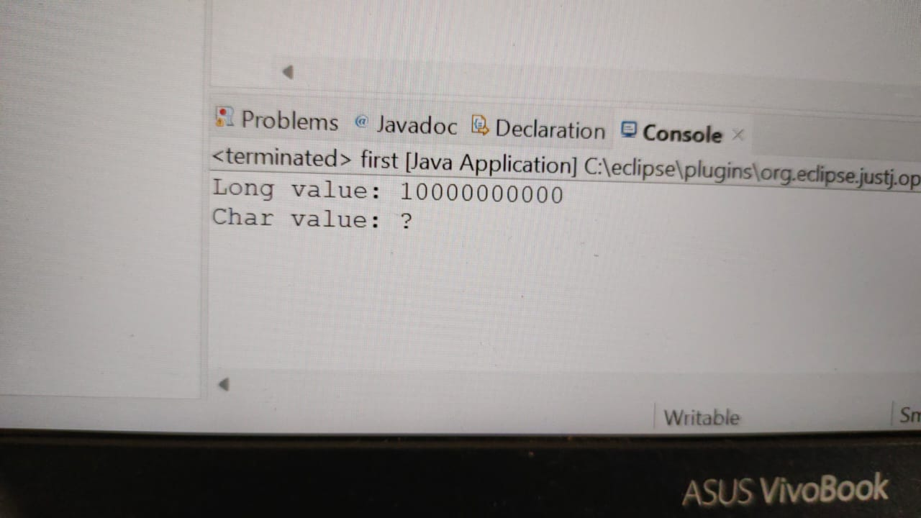

**EXPLICIT CONVERSION**

**LONG TO BOOLEAN**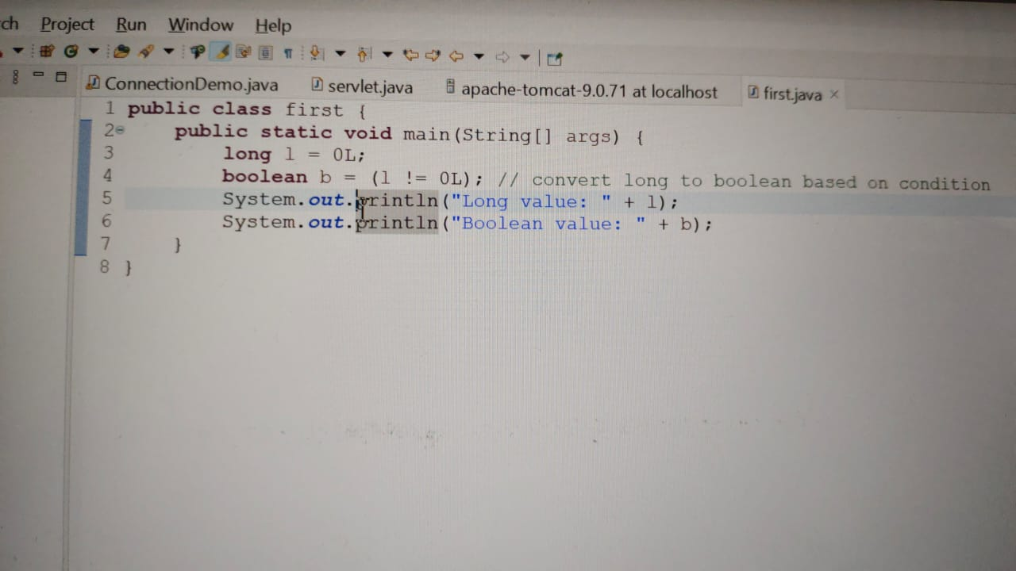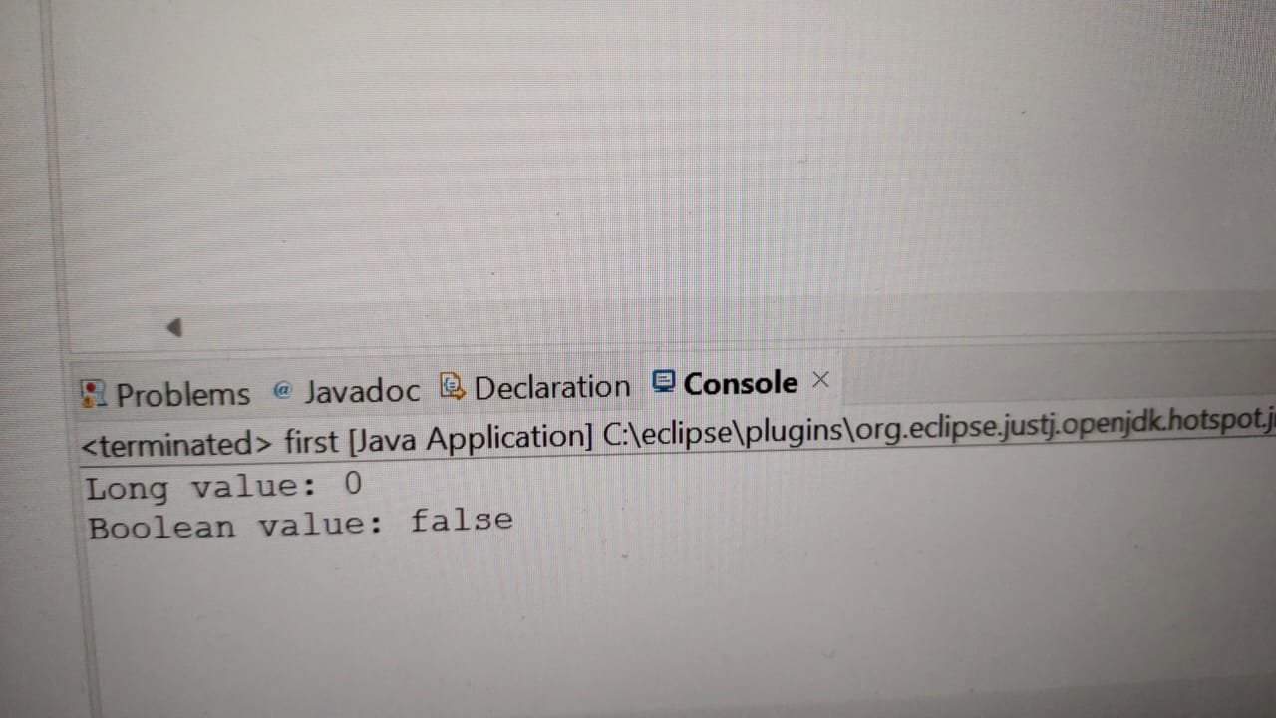

**EXPLICIT CONVERSION**

**FLOAT TO BYTE**

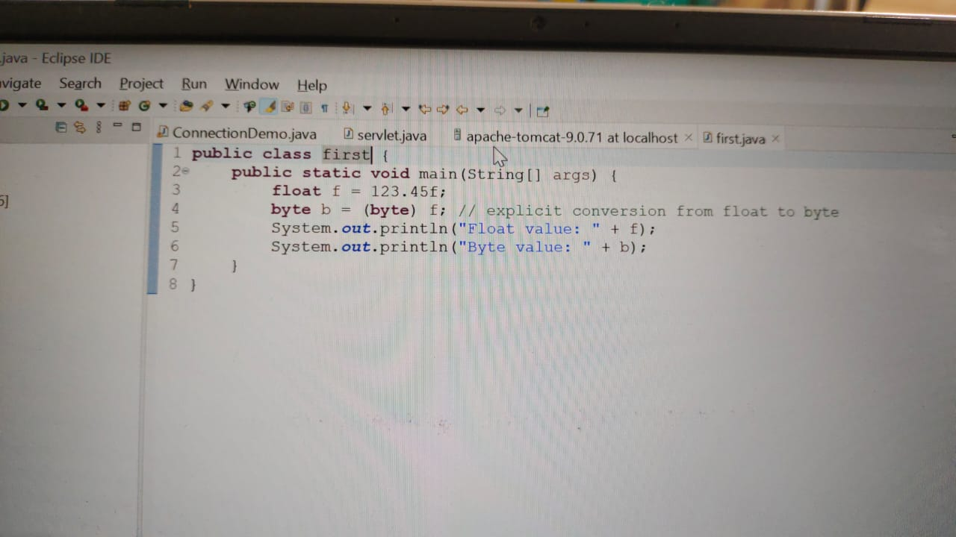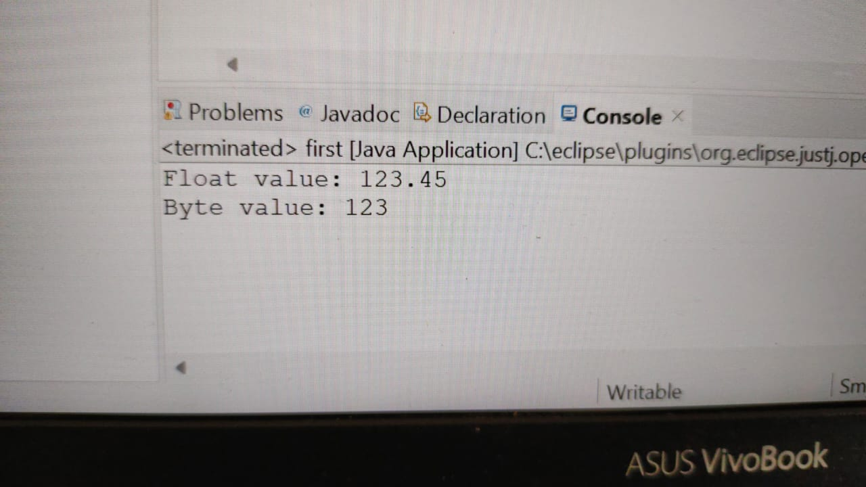

**EXPLICIT CONVERSION**

**FLOAT TO SHORT**

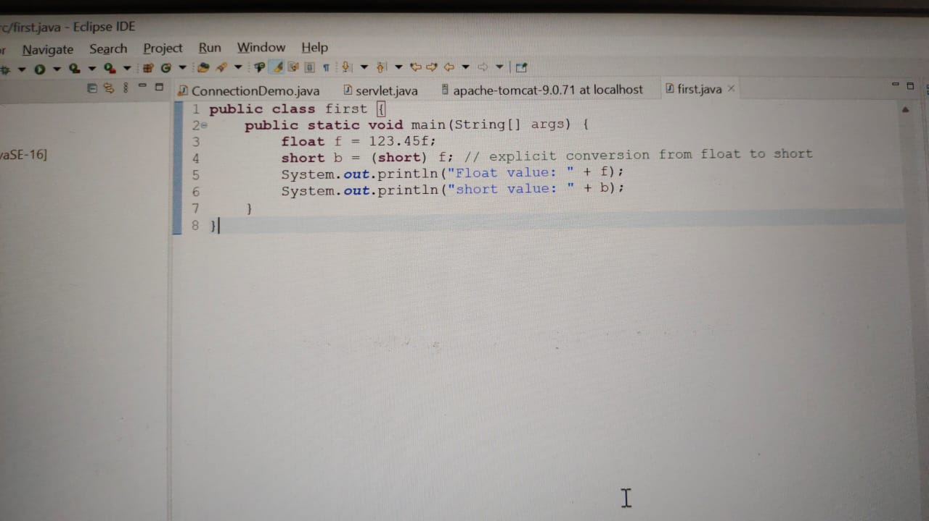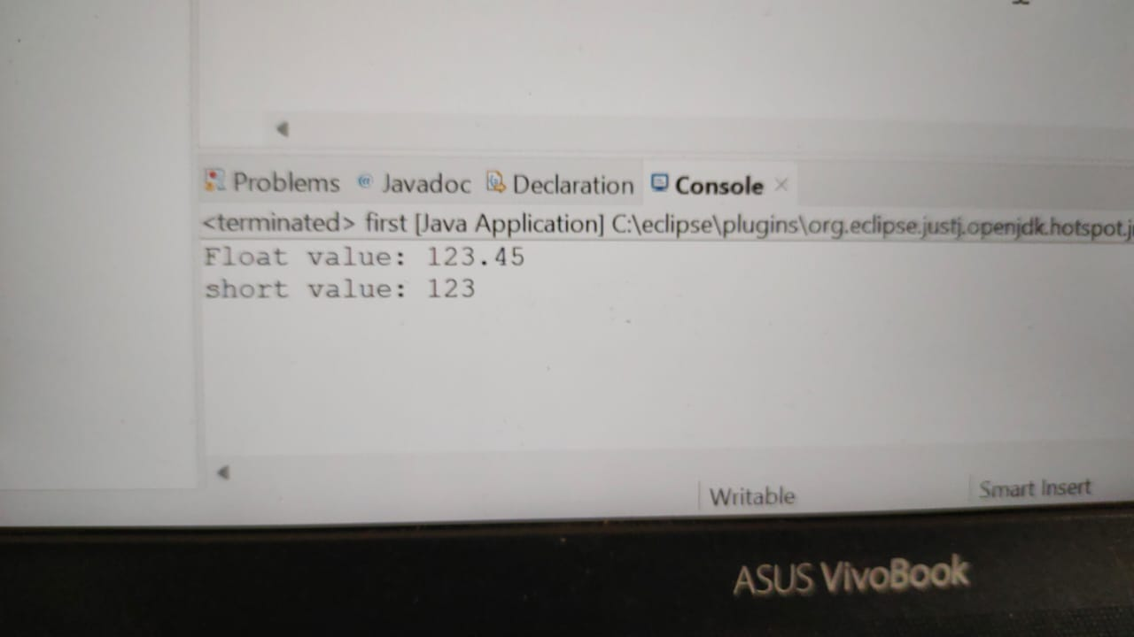

**EXPLICIT CONVERSION**

**FLOAT TO INT**

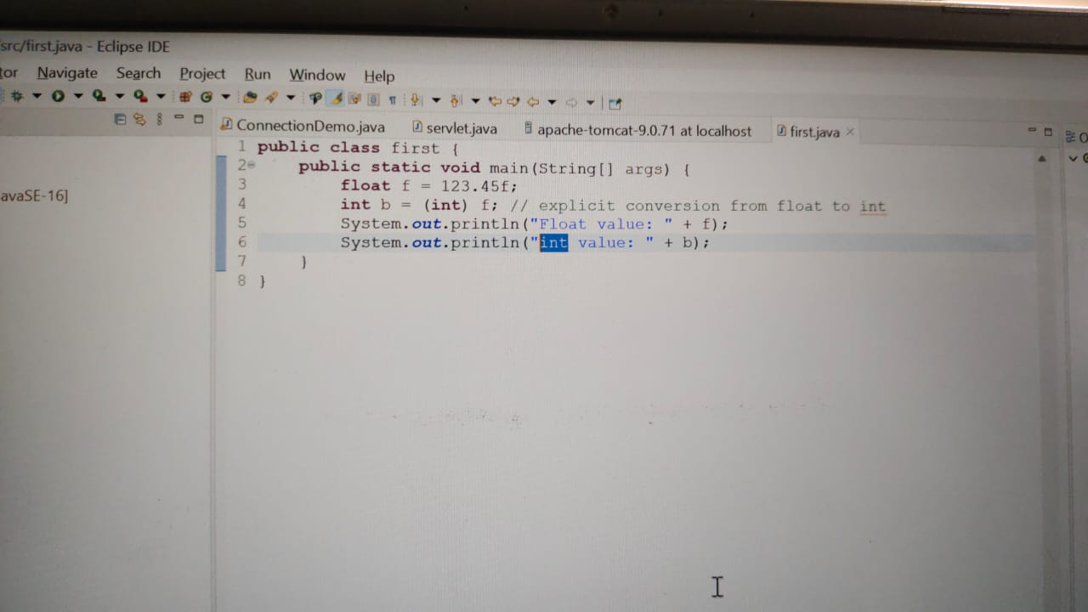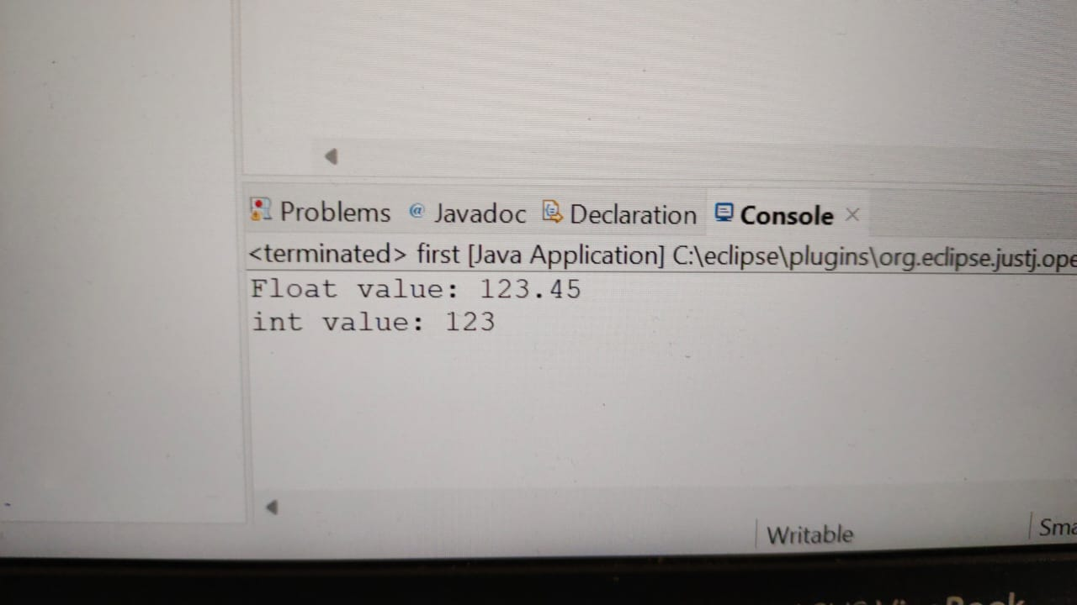

**EXPLICIT CONVERSION**

**FLOAT TO LONG**

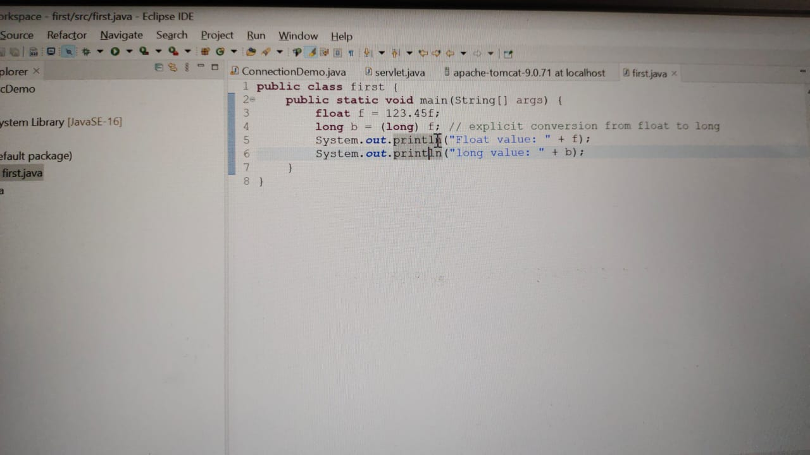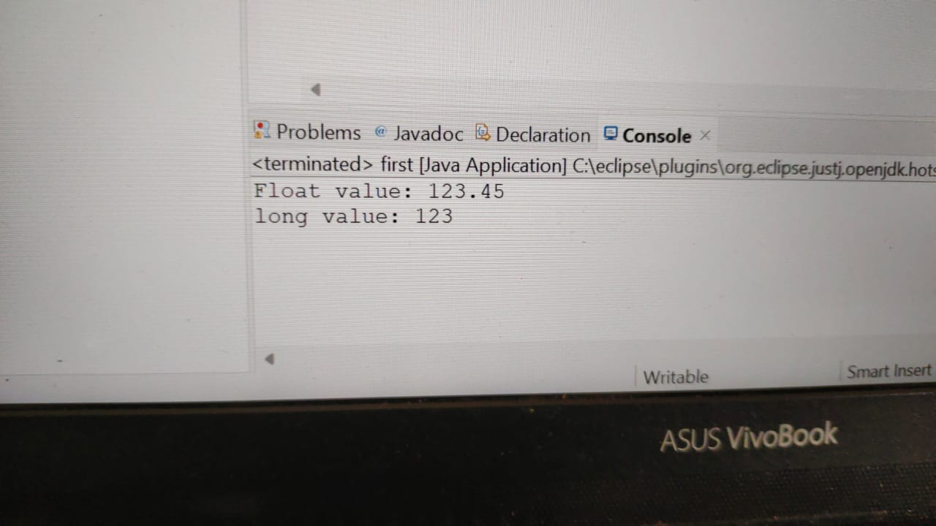

**EXPLICIT CONVERSION**

**FLOAT TO DOUBLE**

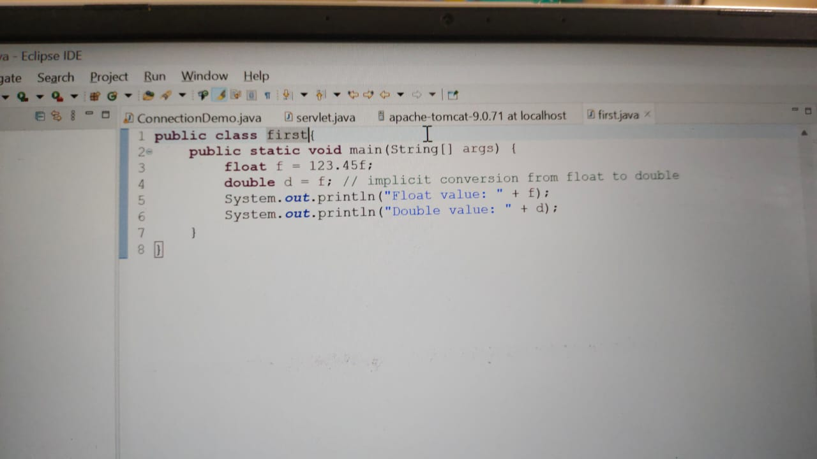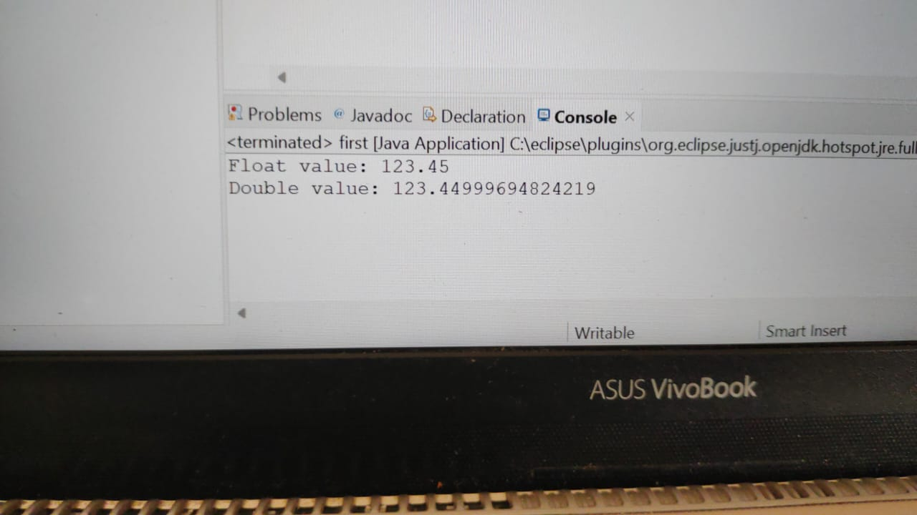

**IMPLICIT CONVERSION**

**FLOAT TO CHARACTER**

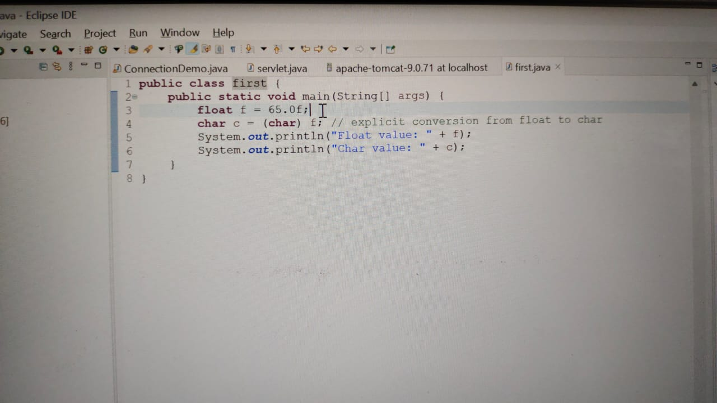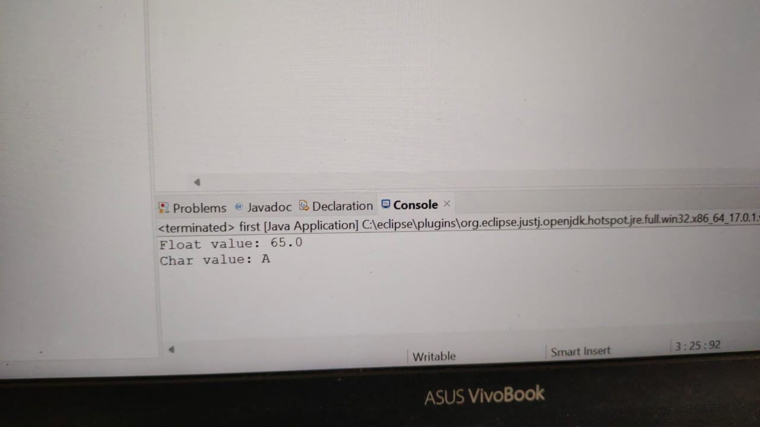

**EXPLICIT CONVERSION**

**FLOAT TO BOOLEAN**

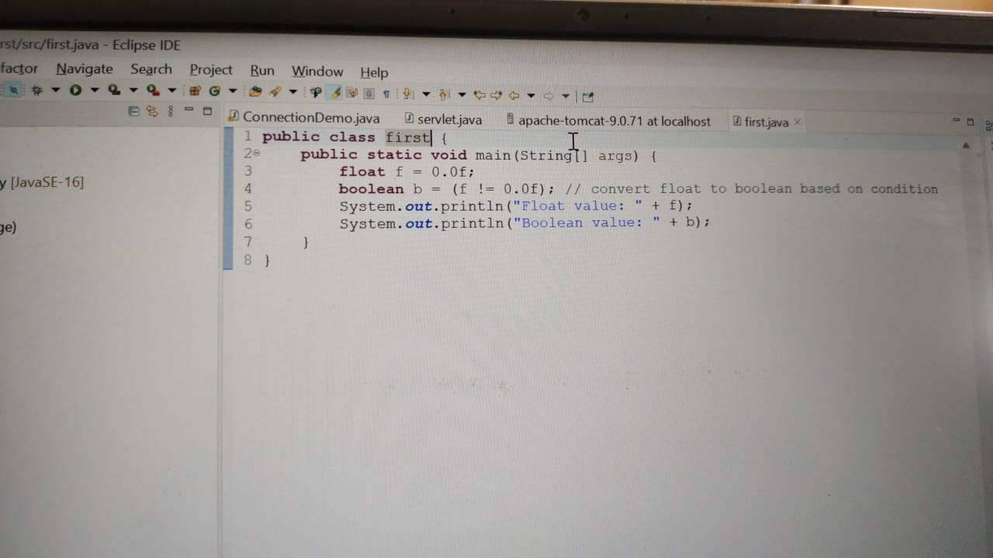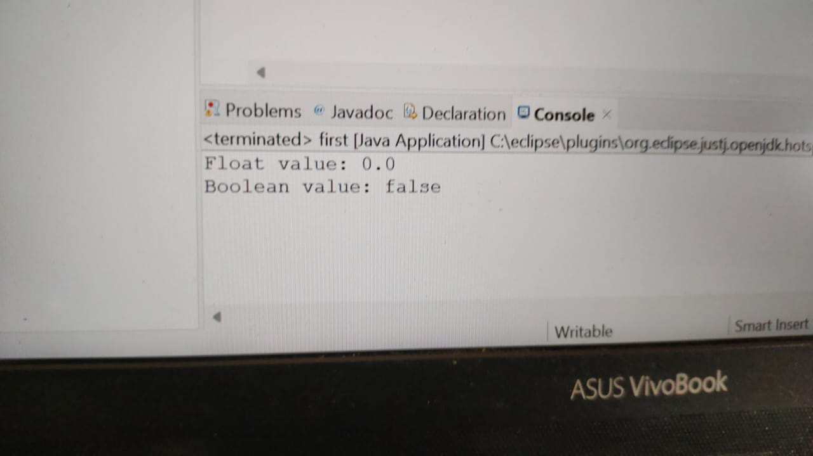

**EXPLICIT CONVERSION**

**DOUBLE TO BYTE**

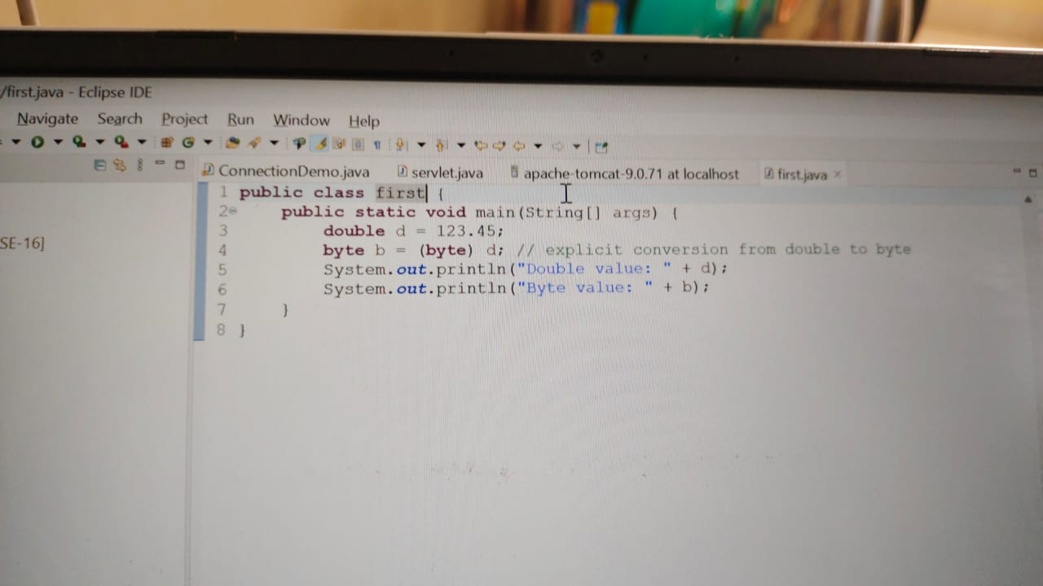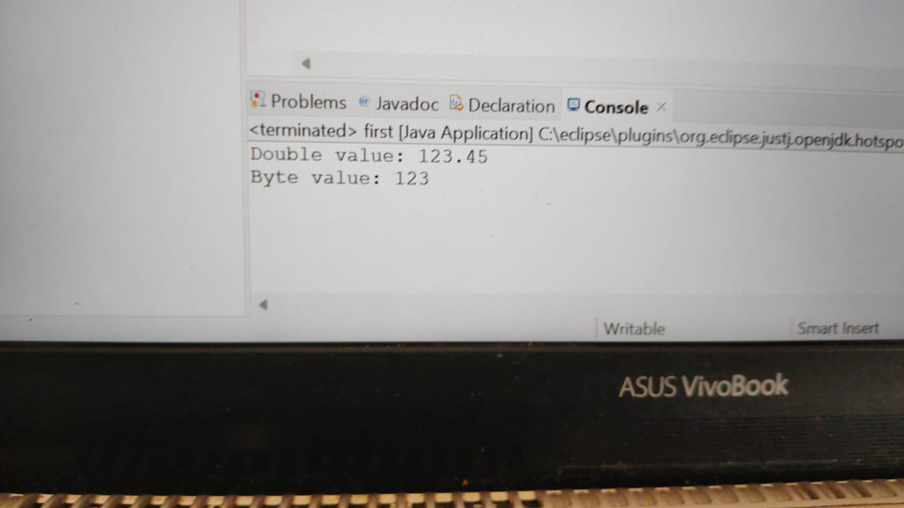

**EXPLICIT CONVERSION**

**DOUBLE TO SHORT**

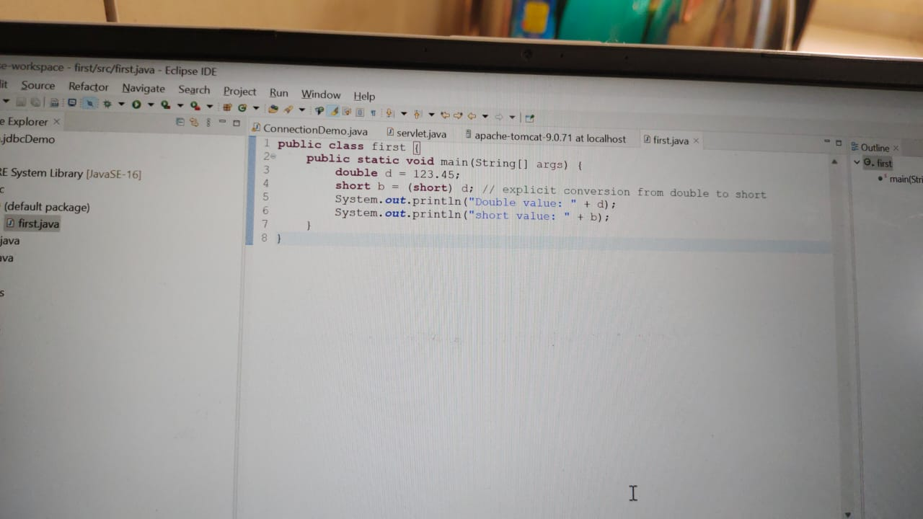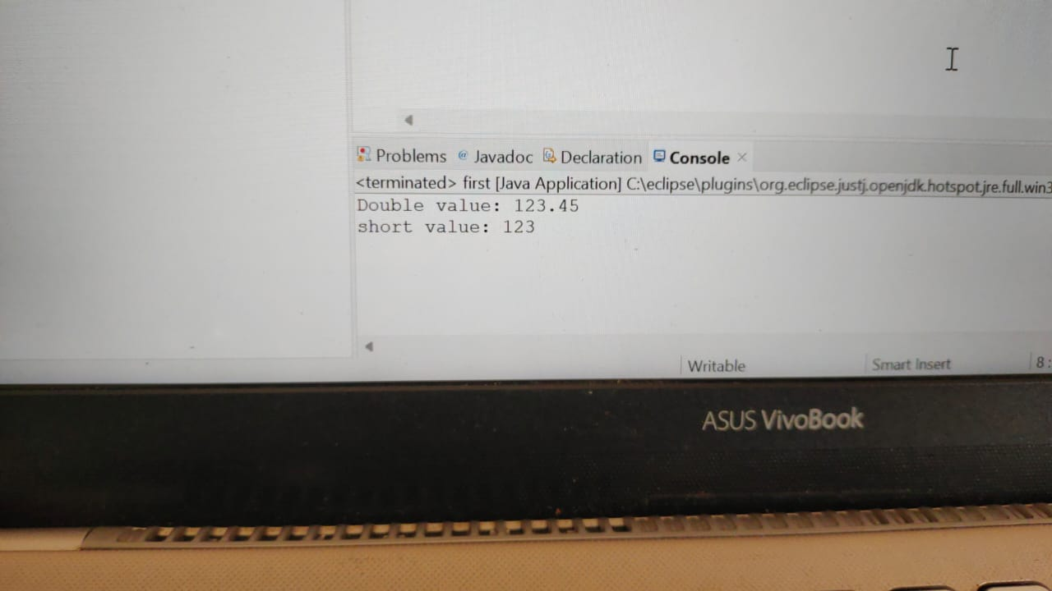

**EXPLICIT CONVERSION**

**DOUBLE TO INT**

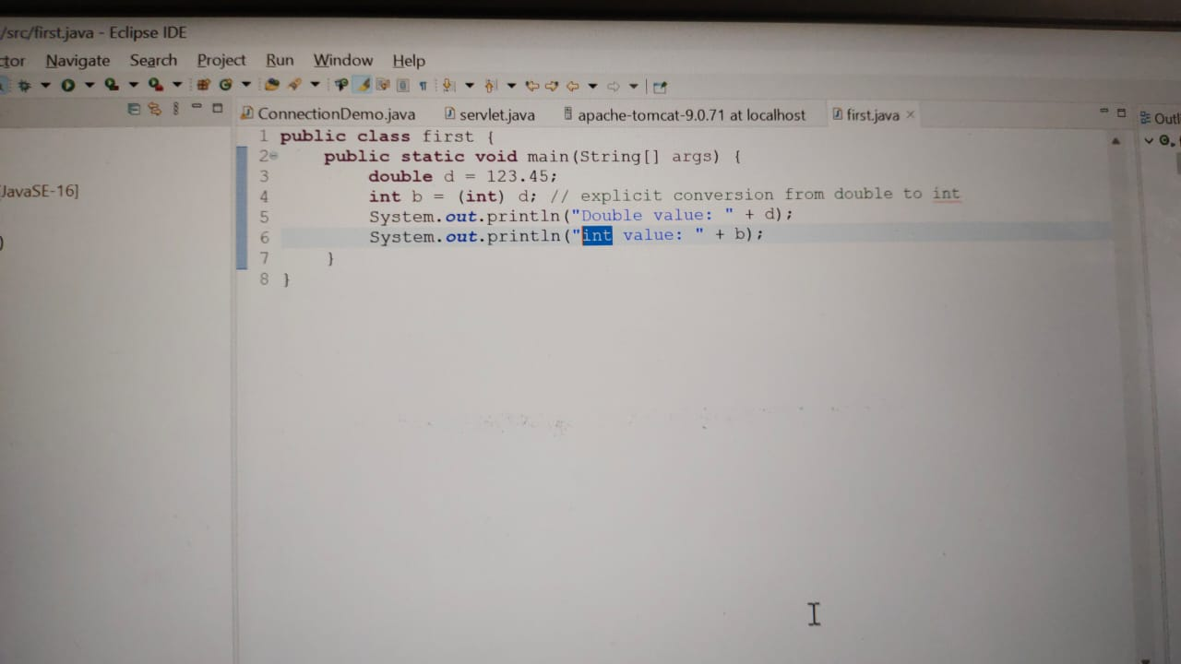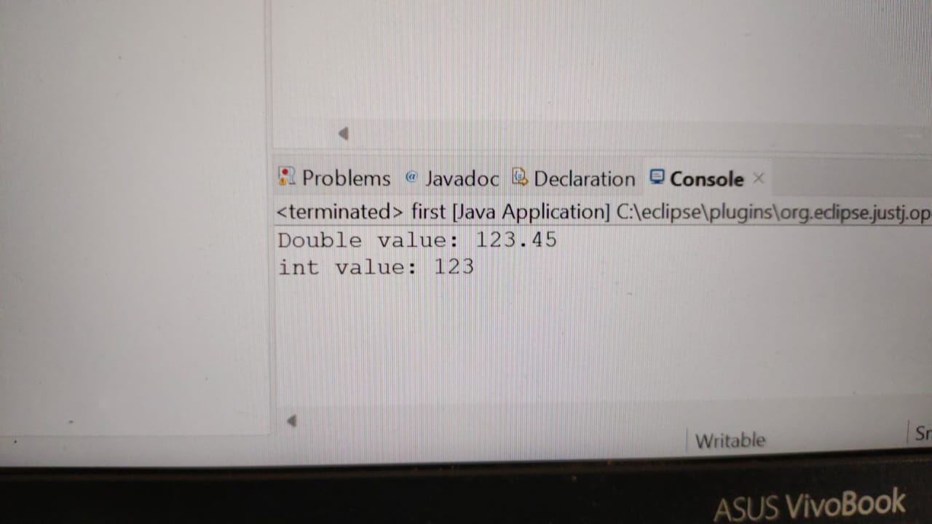

**EXPLICIT CONVERSION**

**DOUBLE TO LONG**

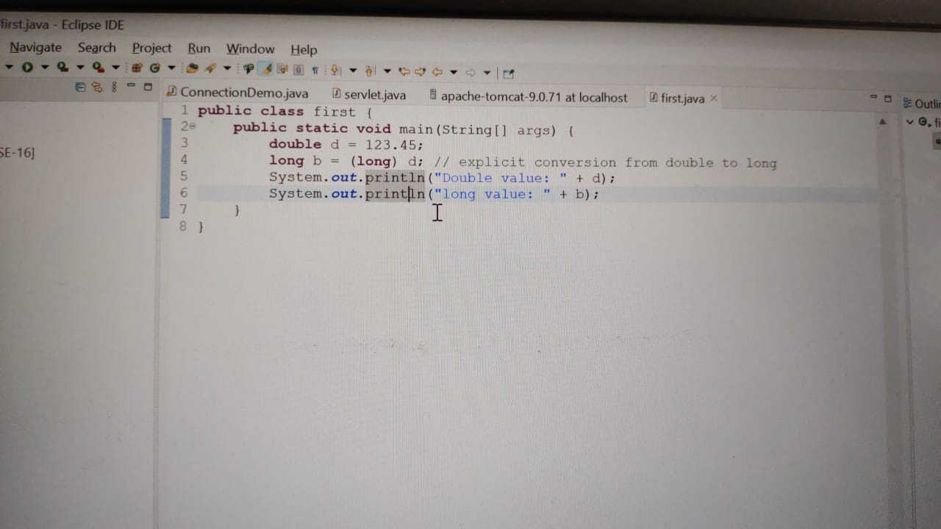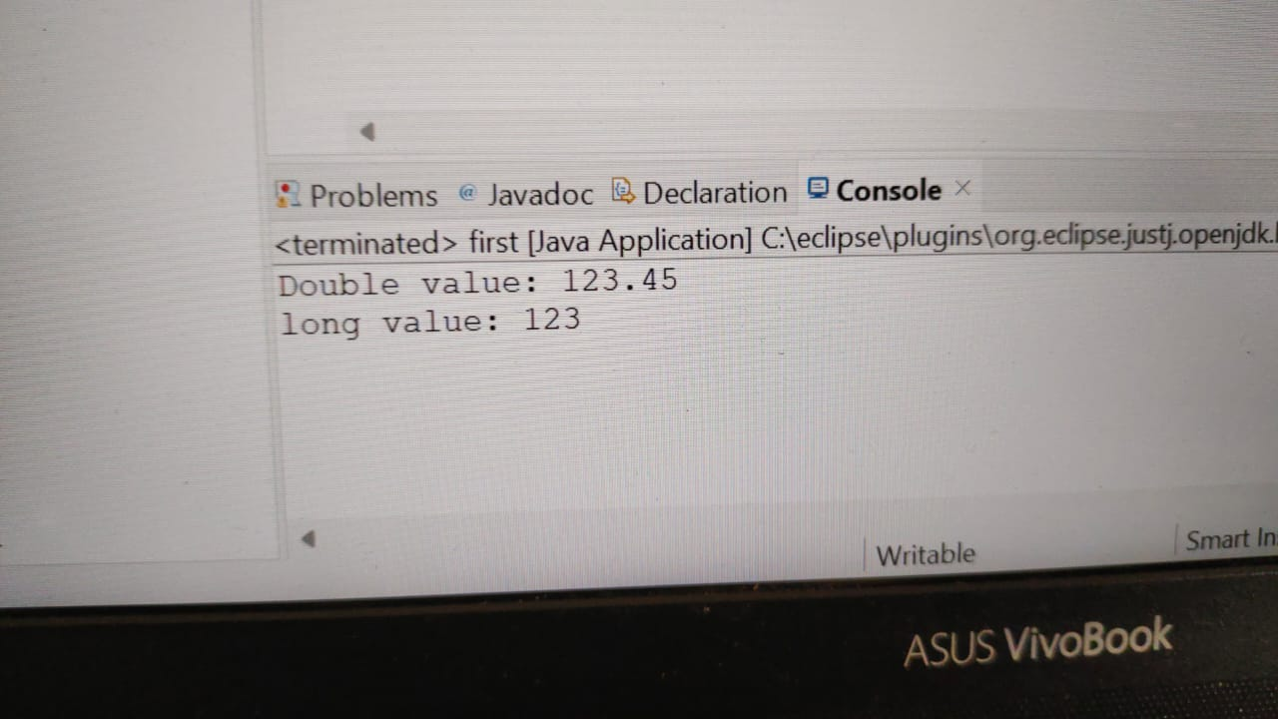

**EXPLICIT CONVERSION**

**DOUBLE TO CHARACTER**

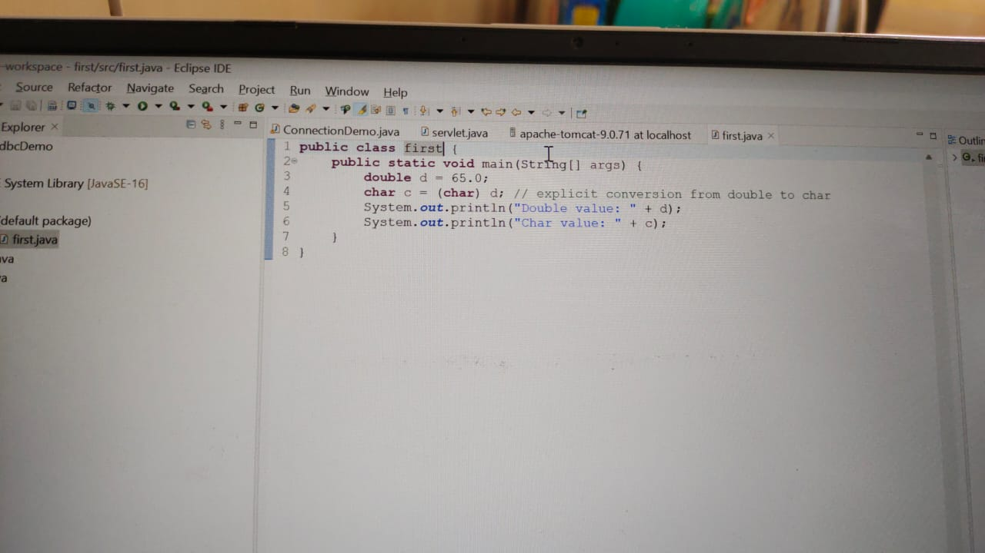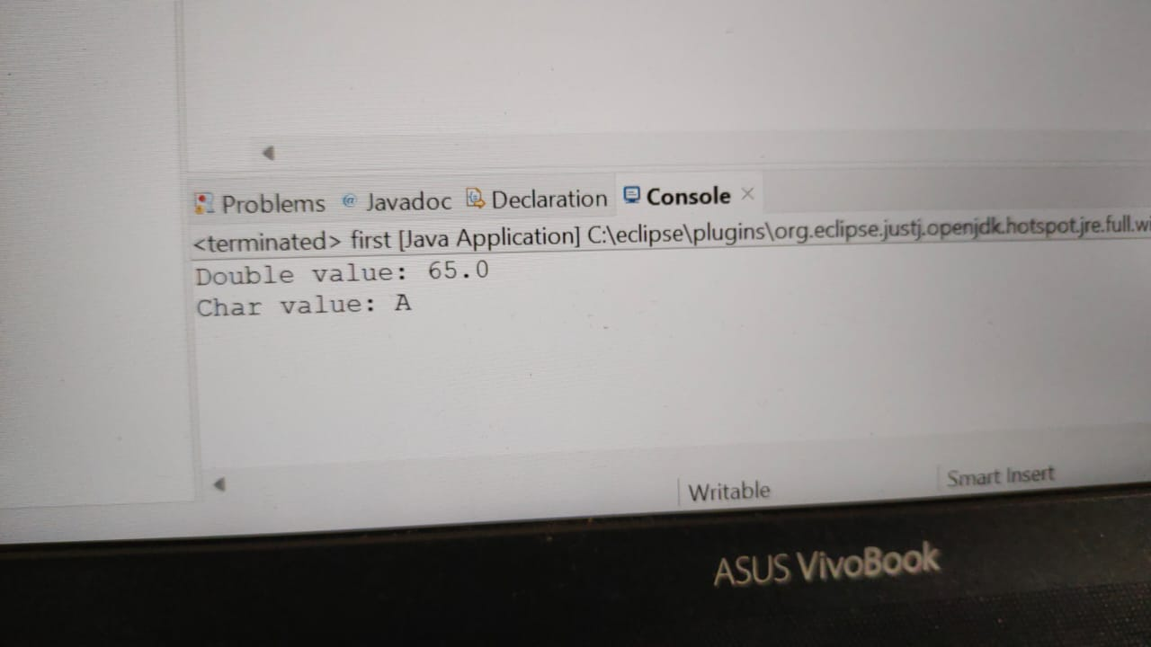

**EXPLICIT CONVERSION**

**DOUBLE TO BOOLEAN**

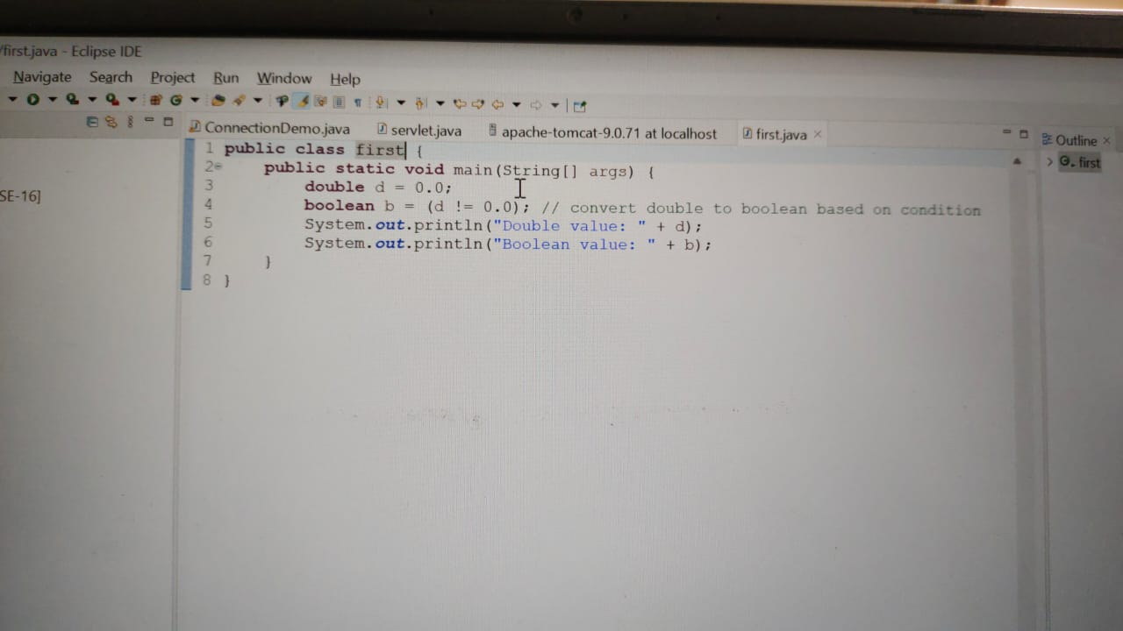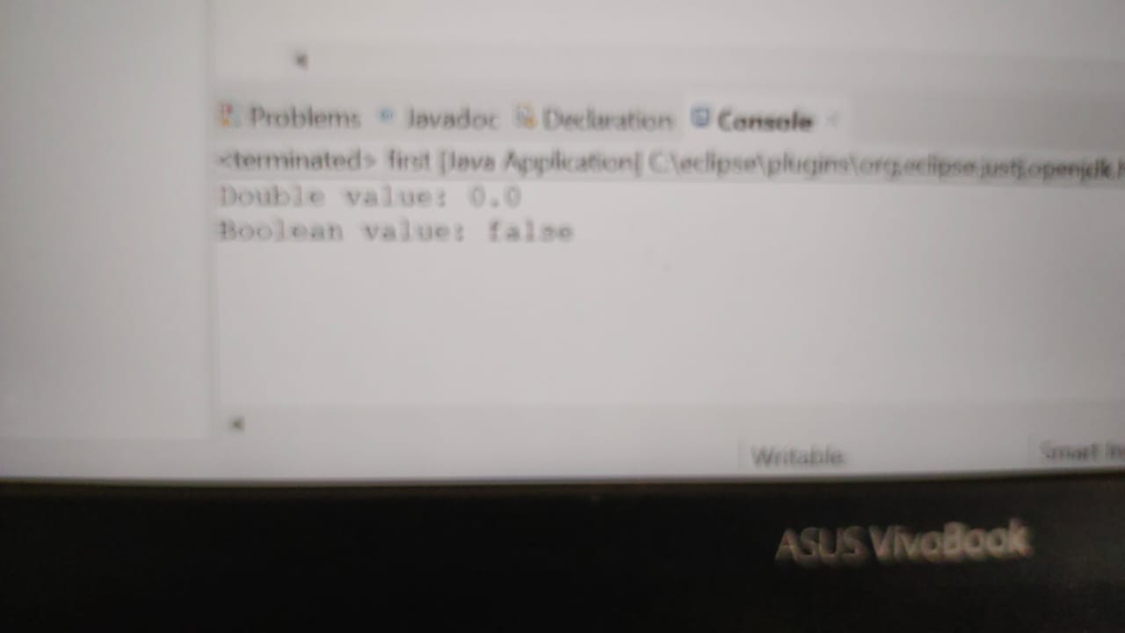

**EXPLICIT CONVERSION**

**CHARACTER TO BYTE**

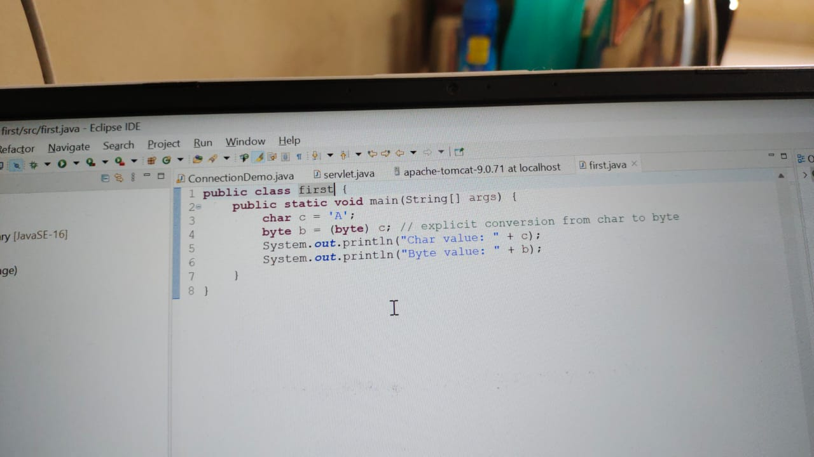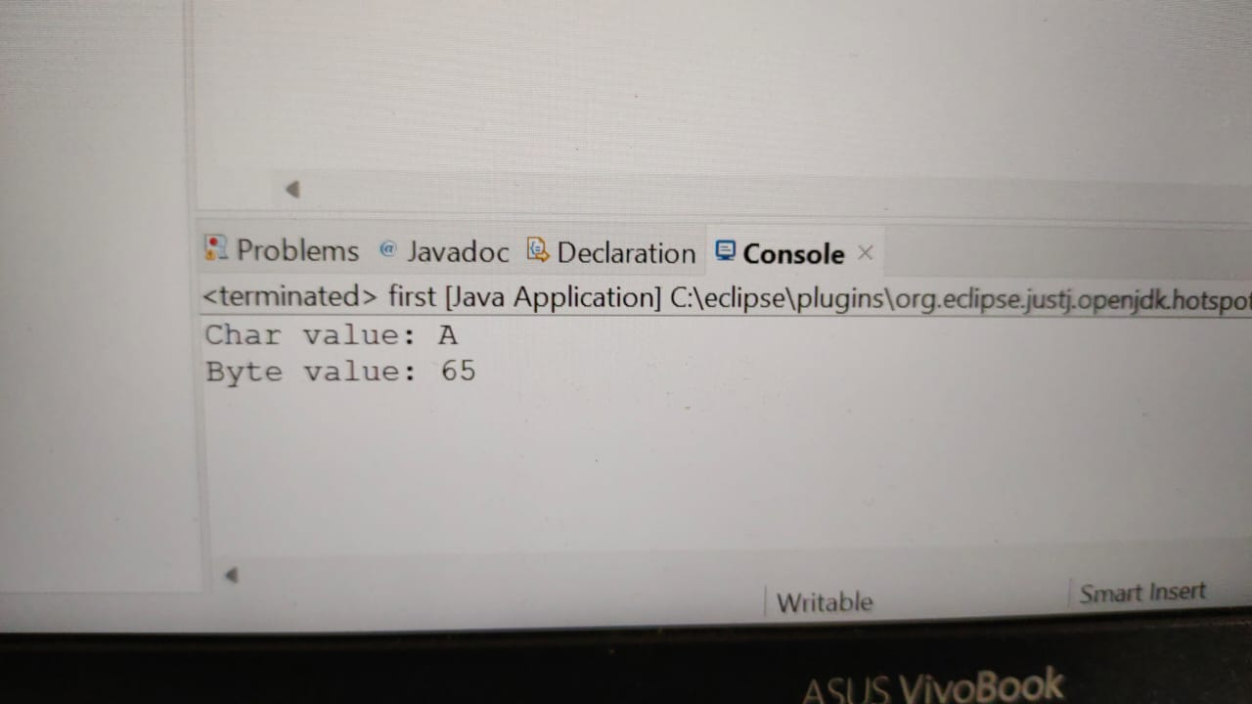

**IMPLICIT CONVERSION**

**CHARACTER TO SHORT**

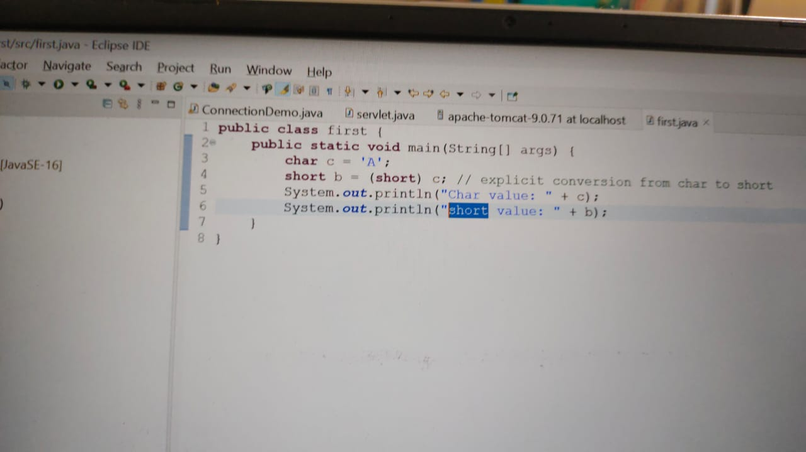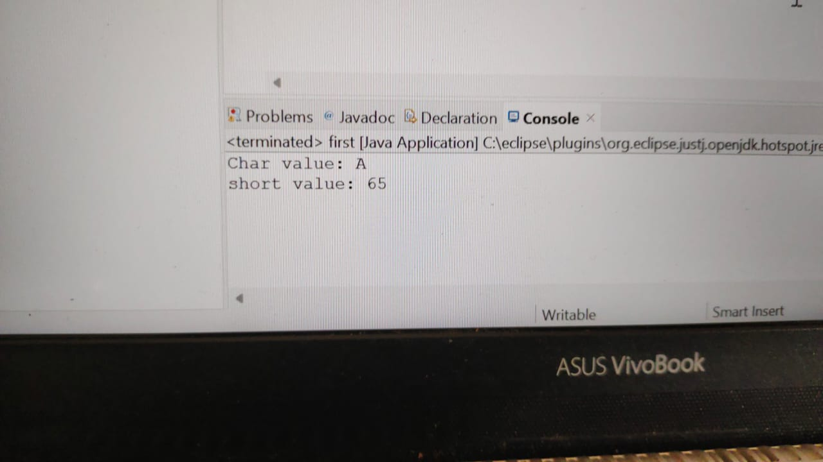

**IMPLICIT CONVERSION**

**CHARACTER TO INT**

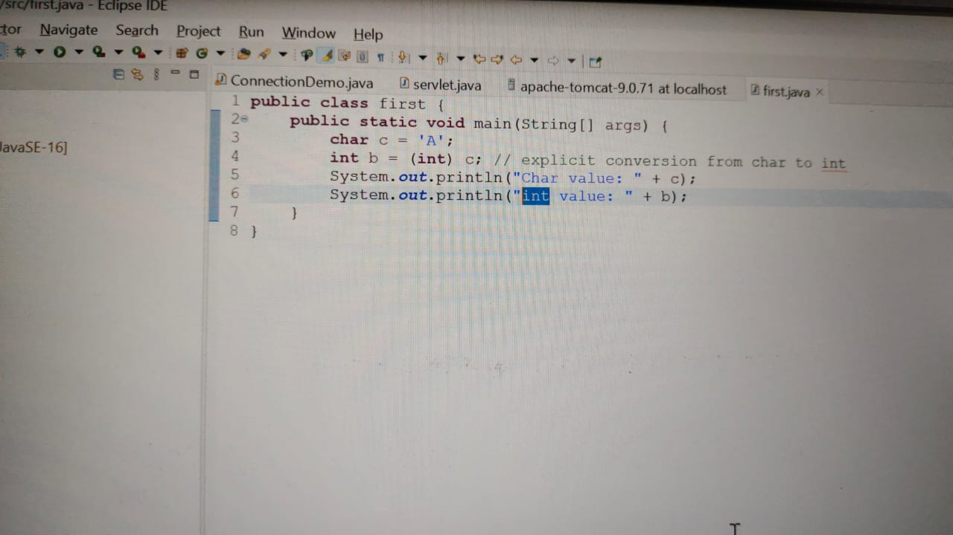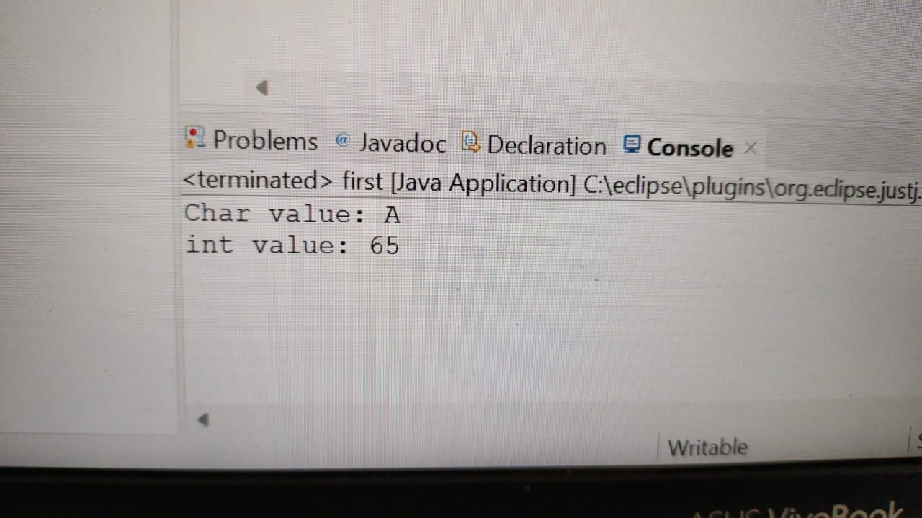

**IMPLICIT CONVERSION**

**CHARACTER TO FLOAT**

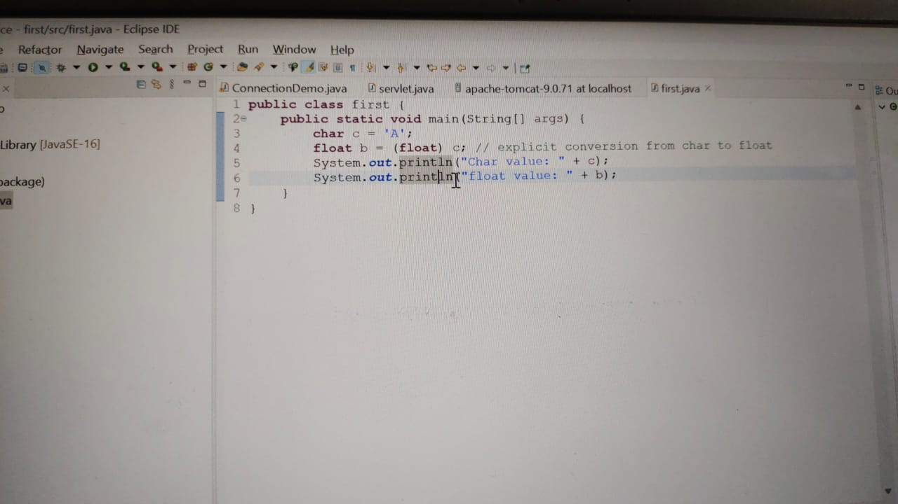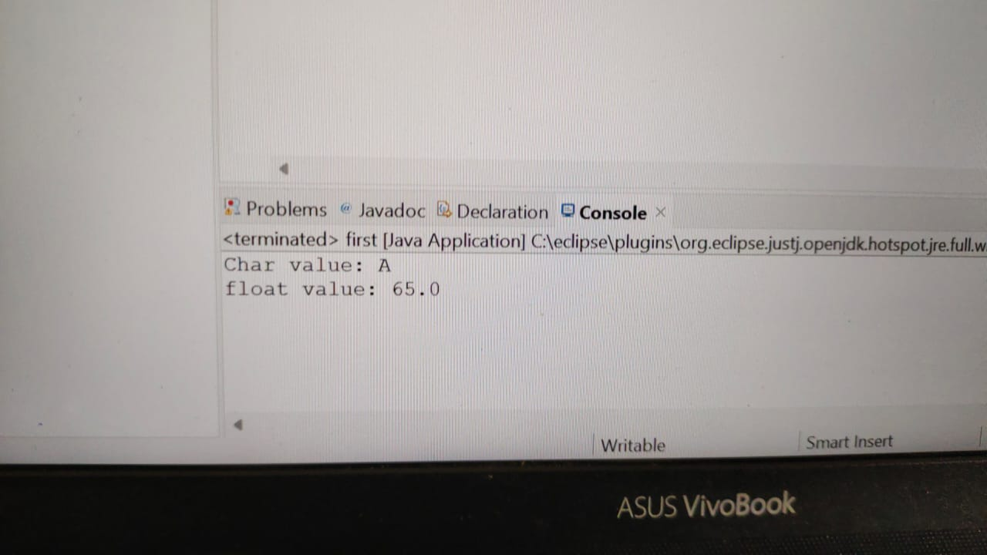

**IMPLICIT CONVERSION**

**CHARACTER TO BOOLEAN**

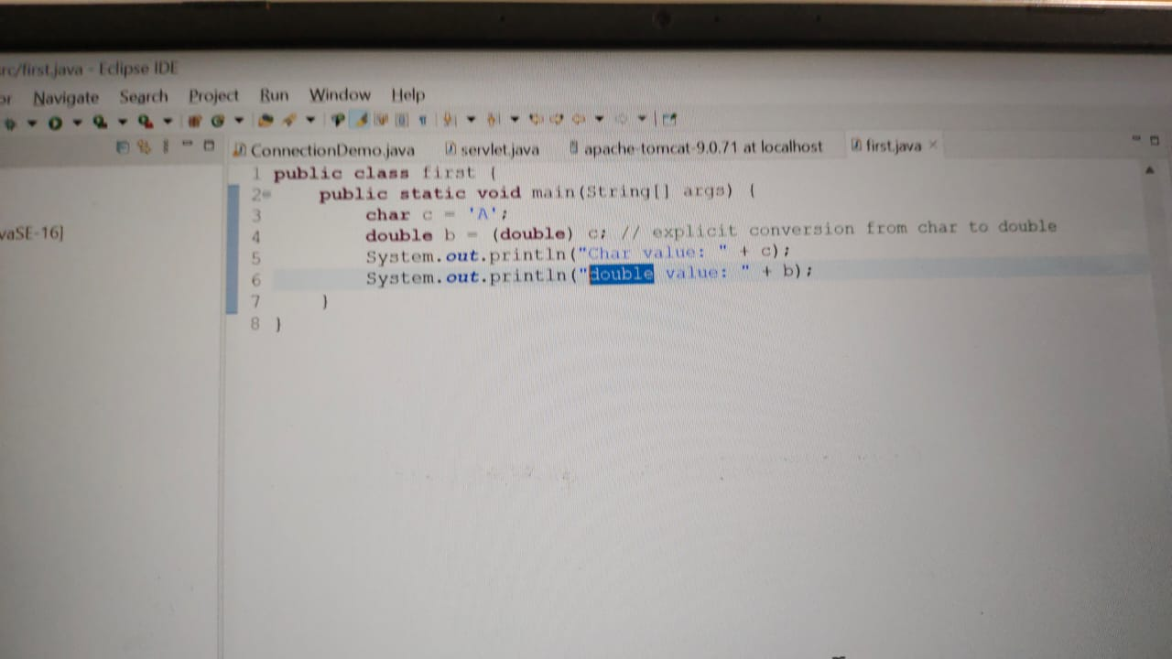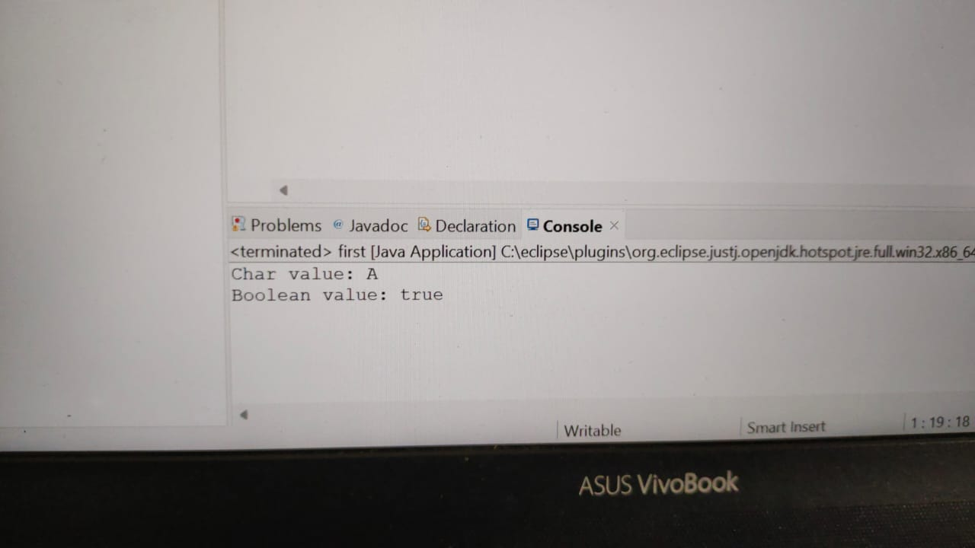

**EXPLICIT CONVERSION**

**BOOLEAN TO BYTE**

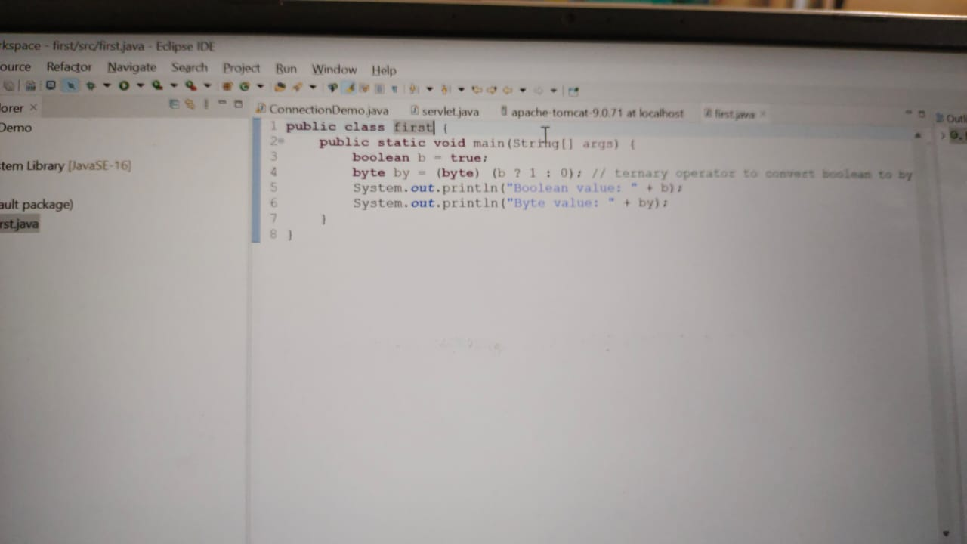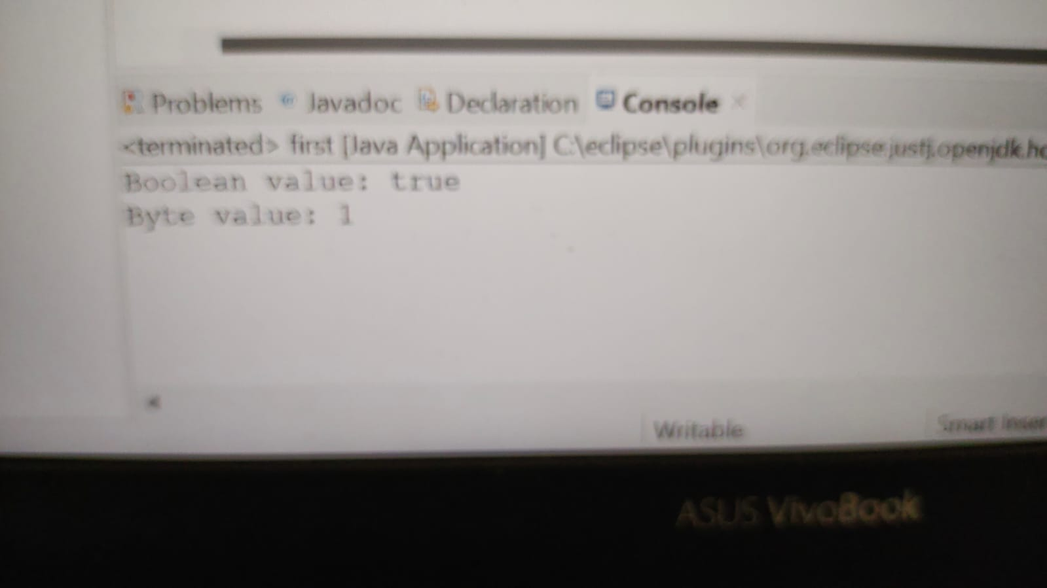

**EXPLICIT CONVERSION**

**BOOLEAN TO SHORT**

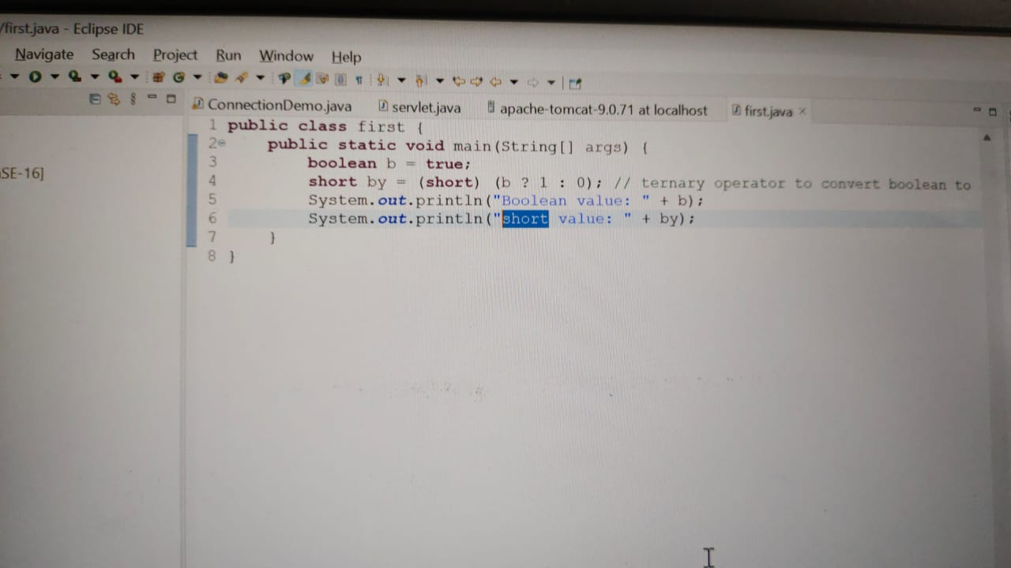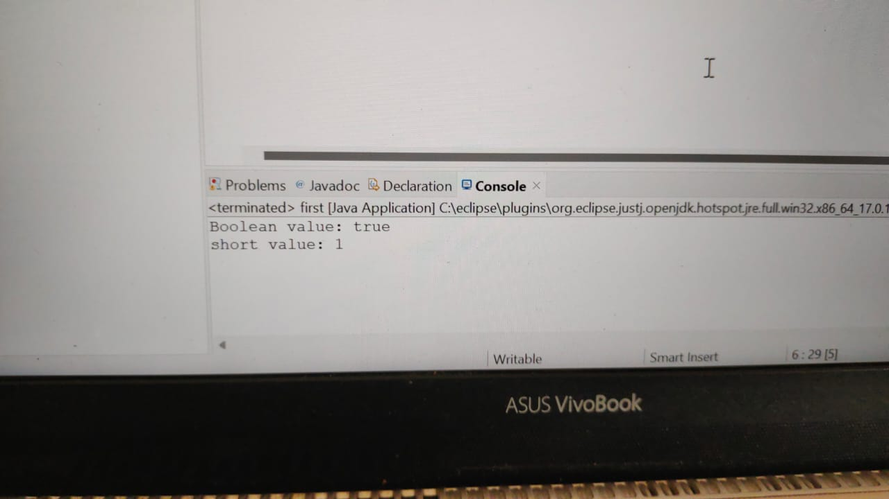

**EXPLICIT CONVERSION**

**BOOLEAN TO INT**

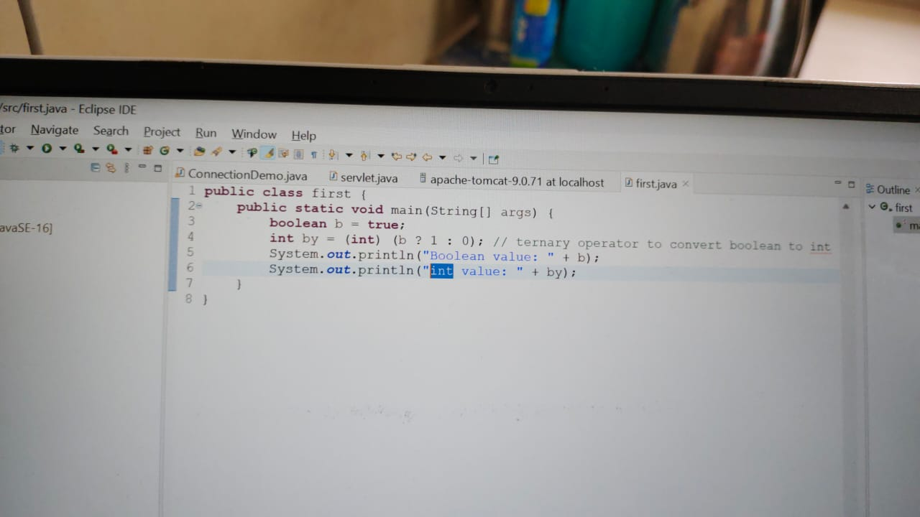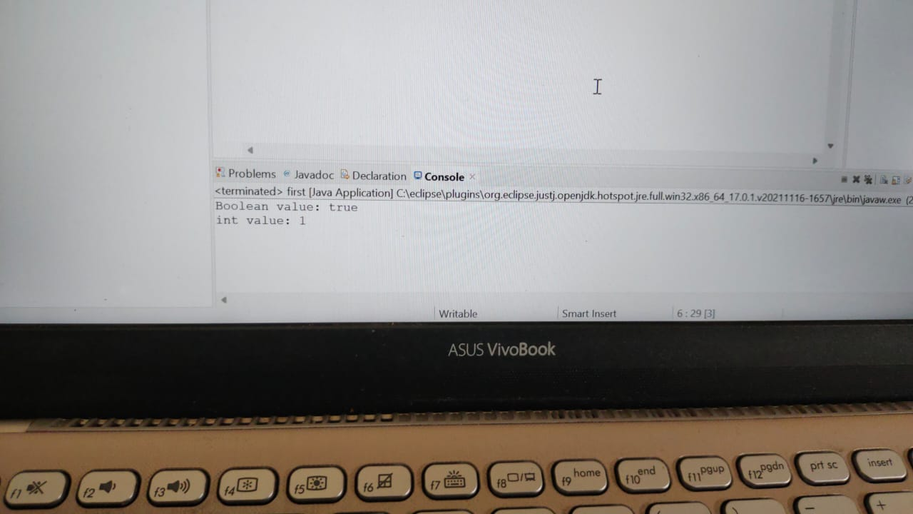

**EXPLICIT CONVERSION**

**BOOLEAN TO LONG**

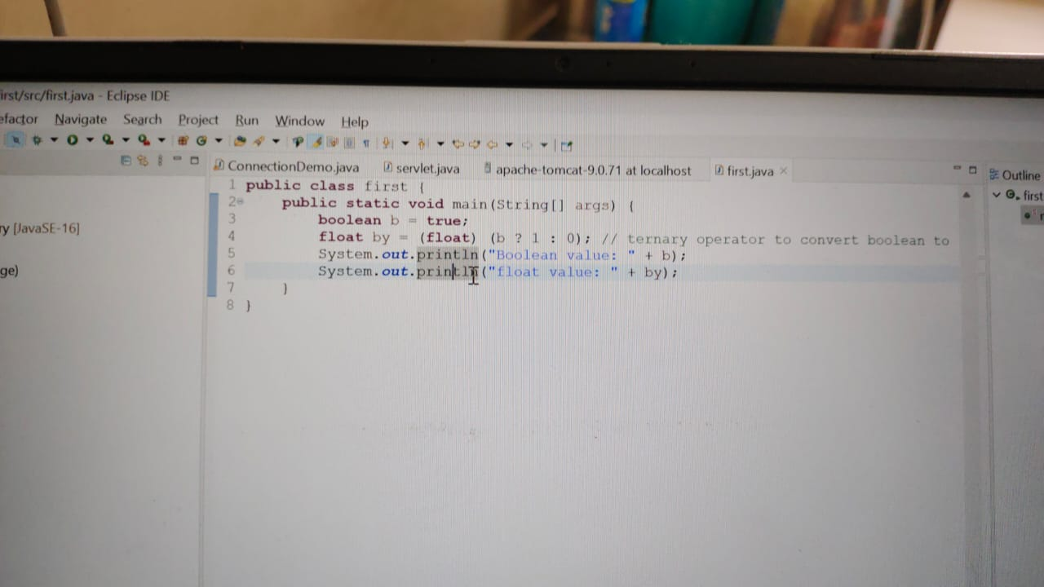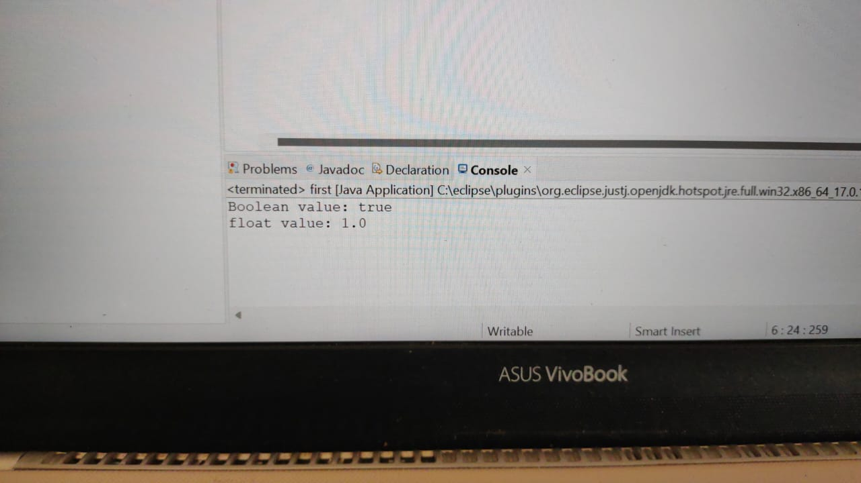

**EXPLICIT CONVERSION**

**BOOLEAN TO DOUBLE**

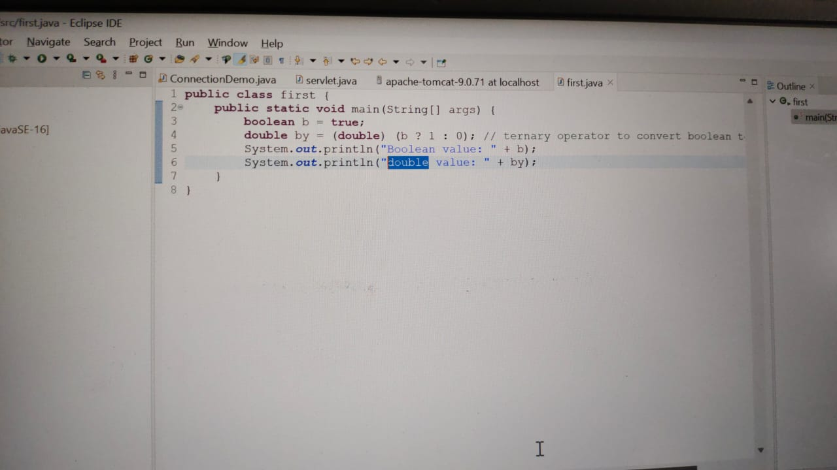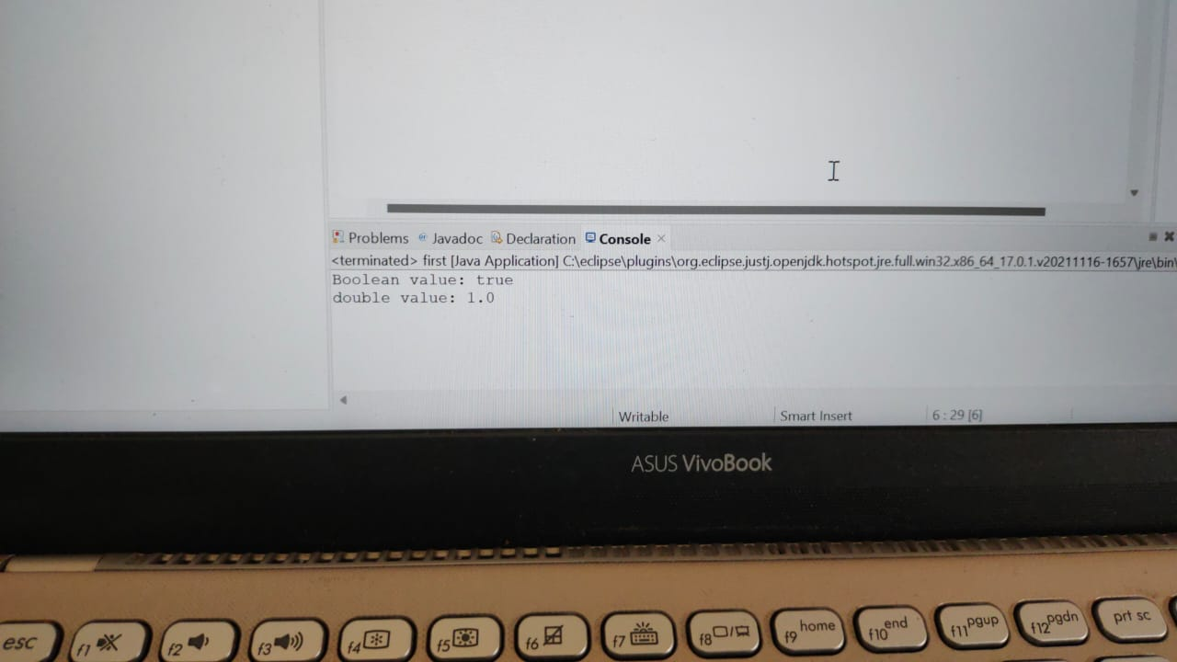

**EXPLICIT CONVERSION**

**BOOLEAN TO CHARACTER**

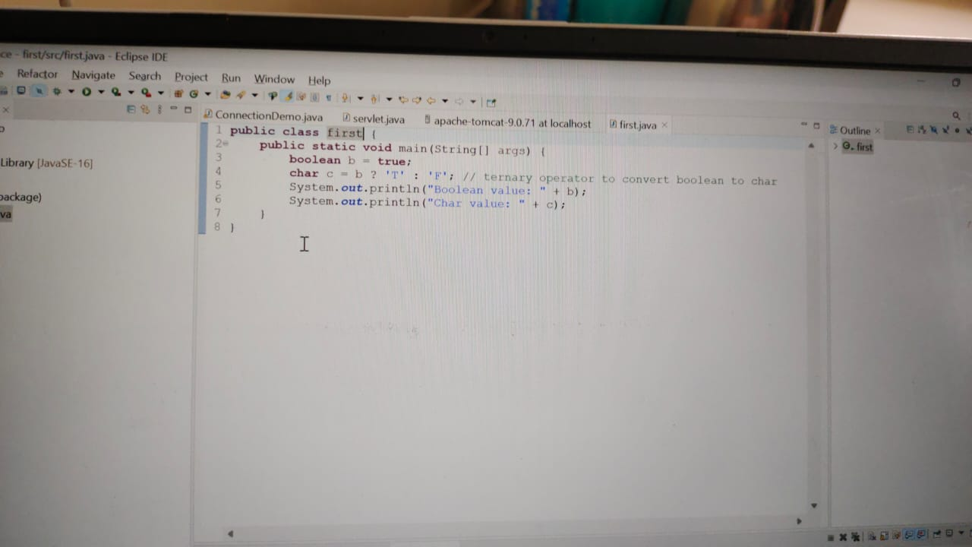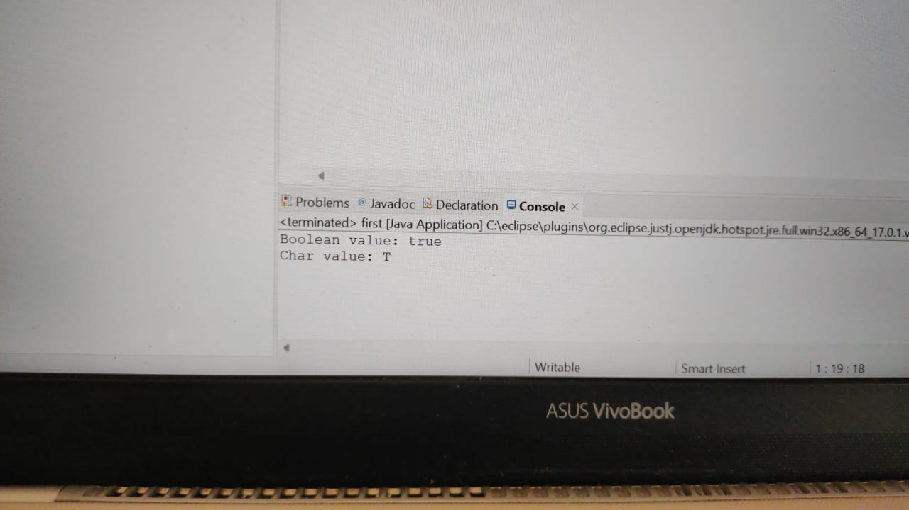

**EXPLICIT CONVERSION**

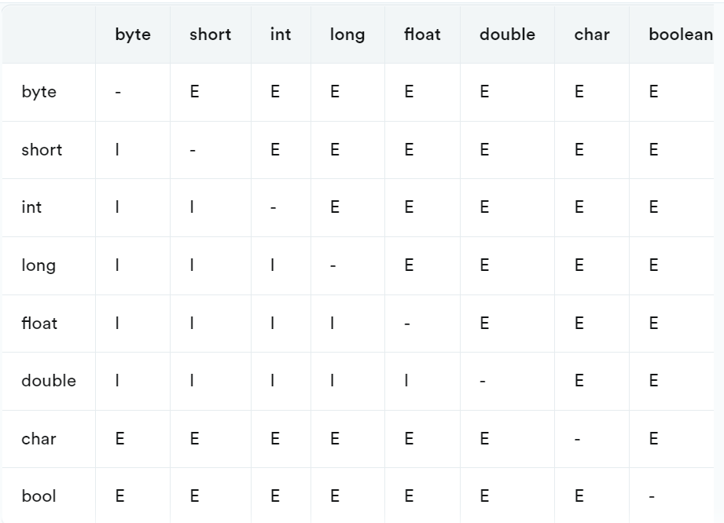

In this chart, "I" represents implicit conversion, "E" represents explicit conversion, and "-" represents no conversion needed.

Implicit conversion means that the conversion is done automatically by the compiler without any extra code needed. For example, when adding an int and a double, the int is implicitly converted to a double before the addition.

Explicit conversion means that the conversion requires an explicit cast operator to be used in the code. For example, when converting a double to an int, an explicit cast operator is needed to specify that the decimal part should be truncated.

Note that some conversions may result in a loss of precision or data, so it's important to be aware of the potential implications when performing type conversions.